9-15-Group 8 – Project 1

Prepared By: Humaira Qadeer

Contents

**Proposition 01: Find by Customer, all orders placed with the date of order placed** 1

Columns From Standard View 1

Columns From Key View 2

Columns from their respective tables in the select clause 2

Order By 3

Problem solving query 3

Sample Relational Output with total number of rows returned (11761) 3

Sample Json Output with total number of rows returned(11761) 3

**Proposition 02 – Find all customers who have not placed orders** 5

Columns from Standard view 5

Columns from key view 6

Columns from their respective tables in the select clause 6

Problem solving Query 7

Sample Relational Output with total number of rows returned(701) 7

Sample JSON Output with total number of rows returned(701) 8

Proposition 03: Find all sales territories that have an IP Address beginning with “192” 9

Columns From Standard view 9

Columns From Key View 10

Columns from their respective table in the select clause 10

Problem Solving Query 11

Sample Relational Output with total number of rows returned (254) 11

Sample JSON Output with total number of rows (254) 11

Proposition 04: Find all customers who placed their first purchase in 2014 and have a postal code that starts with a letter 12

Columns from Standard View 13

Columns from Key View 14

Column from their respective table in the select clause 14

Order By 15

Problem Solving Query 15

Sample Relational output with total number of rows returned (65) 15

Sample Json Output With Total number of rows returned (65) 16

Proposition 05: Figure out customer loyalty level 17

Columns from Standard View 17

Columns from Key View 18

Columns from their respective table in the select clause 18

Order By 18

Problem Solving Query 18

Sample Relational output with total number of rows returned (89) 19

Sample JSON output with total number of rows returned(89) 19

Proposition 06: 21

Columns from Standard View 21

Columns from Key View 21

Columns from their respective table in the select clause 21

Order by 22

Problem Solving Query 22

Sample Relational output with total number of rows returned (26) 23

Sample JSON output with total number of rows returned(26) 23

Proposition 07: Find all the top 10 percent products that had the longest deviation in time from the scheduled start date compared to the actual start date and the scheduled end date compared to the actual end date as well as the process in assembly where the deviation occurred. 24

Columns from Standard View 25

Columns from Key View 26

Columns from their respective table in the select clause 27

Order By 27

Problem Solving Query 27

Sample Relational output with total number of rows returned(1103) 28

Sample JSON output with total number of rows returned(1103) 28

Proposition 08: Find the total salary for each employee based on their pay frequency, commission percentage, pay rate, and bonus as well as their sales location. 30

Columns from Standard View 31

Columns from Key View 32

Columns from their respective table in the select clause 32

Order By 32

Problem solving Query 32

Sample Relational output with total number of rows returned(14) 34

Sample JSON output with total number of rows returned(14) 34

Proposition 09: Based on the year and month, which products were scrapped, what was the quantity of the products that were scrapped, how much was the total cost of scrapping those products and why were they scrapped? 36

Columns from Standard View 37

Columns from Key View 38

Columns from their respective table in the select clause 38

Order By 38

Problem Solving Query 39

Sample relational out with rows returned (93) 40

Sample JSON Output with total number of rows returned(93) 40

Proposition 10: What was the growth in territories for each consecutive year, beginning with the first order year, for internet sales? 41

Columns from Standard View 42

Columns from Key View 42

Columns from their respective table in the select clause 42

Problem Solving Query 43

Sample Relational output with total number of rows returned(4) 43

Sample JSON output with total number of rows returned(4) 44

Proposition 11: Find the total amount of orders placed based upon the sales reason 45

Columns from Standard View 46

Columns from Key View 46

Columns from their respective table in the select clause 46

Order By 47

Problem Solving Query 47

Sample relational output with total number of rows returned(7) 48

Sample JSON output with total number of rows returned(7) 49

Proposition 12: Find the total value in sales for each territory 49

Columns from Standard View 50

Columns from Key View 51

Columns from their respective table in the select clause 51

Order by 51

Problem Solving Query 51

Sample Relational Output with total number of rows returned(10) 52

Sample Relational Output with total number of rows returned(10) 53

Proposition 13: Find the amount of orders that were placed based on the color of the product and the age of the customer to determine the preferences of product colors by age 54

Columns from Standard View 54

Columns from Key View 56

Columns from their respective table in the select clause 56

Order By 56

Problem Solving Query 56

Sample Relational output with total number of rows returned(293) 57

Sample JSON Output with total number of rows returned(411) 57

Proposition 14: 58

Columns from Standard View 58

Columns from Key View 58

Columns from their respective table in the select clause 58

Order By 58

Problem Solving Query 59

Sample Relational Output with total number of rows returned(411) 60

Sample JSON Output with total number of rows returned(411) 61

Proposition 15: Determine whether or not products that have a unit price greater than 1000 are in stock during the month of june and december for each year 62

Columns from Standard View 62

Columns from Key View 63

Columns from their respective table in the select clause 63

Order By 63

Problem Solving Query 63

Sample Relational output with total number of rows returned(350) 65

Sample JSON output with total number of rows returned(350) 65

Proposition 16: How many years did each employee work up to the current date? 66

Columns from Standard View 67

Columns from Key View 67

Columns from their respective table in the select clause 67

Order By 68

Problem Solving Query 68

Sample Relational output with total number of rows returned(296) 69

Sample JSON output with total number of rows returned(296) 69

Proposition 17: Find all the products that were rejected 70

Columns from Standard View 71

Columns from Key View 72

Columns from their respective table in the select clause 72

Order By 72

Problem Solving Query 72

Sample Relational output with total number of rows returned(100) 74

Sample JSON output with total number of rows returned(100) 74

Proposition 18:Find the top 5 most expensive products to ship 75

Columns from Standard View 76

Columns from Key View 77

Columns from their respective table in the select clause 77

Order by 77

Problem Solving Query 78

Sample Relational output with total number of rows returned(5) 79

Sample JSON output with total number of rows returned(5) 79

Proposition 19 Find out if shipments were shipped on time 80

Columns from Standard View 81

Columns from Key View 81

Columns from their respective table in the select clause 82

Order By 82

Problem Solving Query 82

Sample Relational output with total number of rows returned(271) 83

Sample JSON output with total number of rows returned(271) 84

Proposition 20: Find the top 10 with ties results for the average amount of actual expenses on 12/29/2010 and include the organization, department, account description and type of account 86

Columns from Standard View 86

Columns from Key View 87

Columns from their respective table in the select clause 87

Order By 87

Problem Solving Query 87

Sample Relational output with total number of rows returned(11) 89

Sample JSON output with total number of rows returned(11) 89

# Proposition 01: Find by Customer, all orders placed with the date of order placed

Explanation: Find the salesorderid, customerid, accountnumber and orderdate for all orders

placed in the year 2014

## Columns From Standard View



## Columns From Key View



## Columns from their respective tables in the select clause

|  |  |
| --- | --- |
| Table Name | Column Name |
| SalesOrderHeader | SalesOrderID  OrderDate |
| Customer | CustomerId  AccountNumber |

## Order By

|  |  |  |
| --- | --- | --- |
| Table Name | Column Name | Sort Order |
| Customer | CustomerId |  |
| Order | OrderDate |  |

## Problem solving query

USE AdventureWorks2017;

SELECT OH.SalesOrderID,

C.CustomerID,

C.AccountNumber,

OH.OrderDate

FROM Sales.Customer AS C

INNER JOIN Sales.SalesOrderHeader AS OH

ON C.CustomerID = OH.CustomerID

WHERE YEAR(OH.OrderDate) = 2014

ORDER BY OH.CustomerID,

OH.OrderDate;

--FOR JSON PATH, ROOT('CustomerOrders'), INCLUDE_NULL_VALUES;

## Sample Relational Output with total number of rows returned (11761)

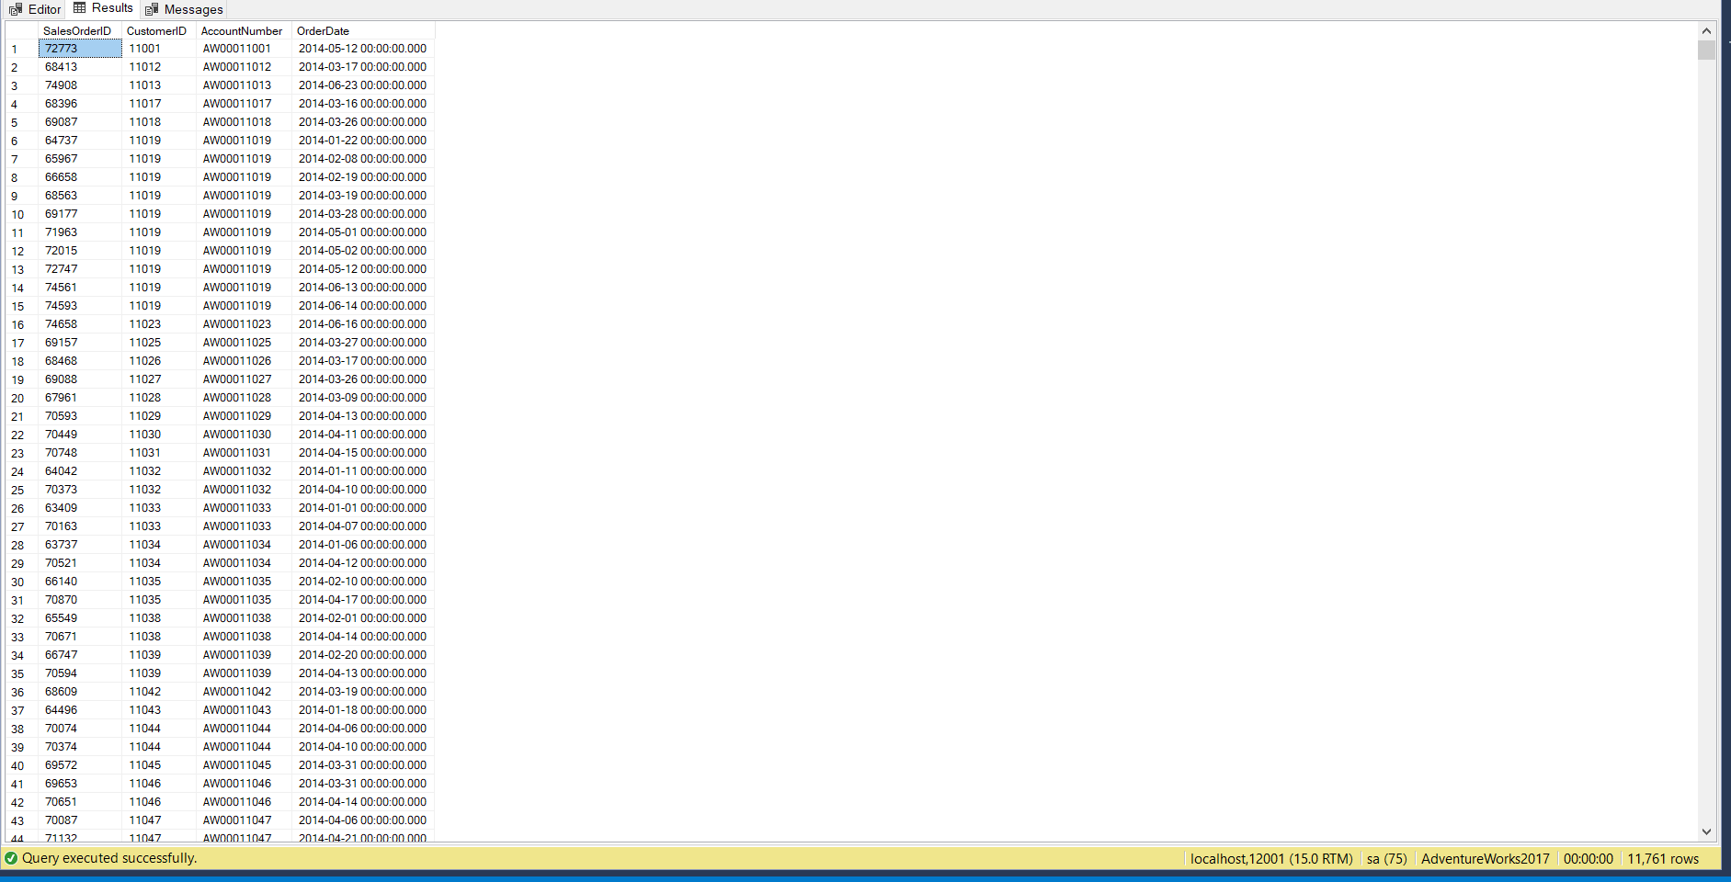

## Sample Json Output with total number of rows returned(11761)

USE AdventureWorks2017;

SELECT OH.SalesOrderID,

C.CustomerID,

C.AccountNumber,

OH.OrderDate

FROM Sales.Customer AS C

INNER JOIN Sales.SalesOrderHeader AS OH

ON C.CustomerID = OH.CustomerID

WHERE YEAR(OH.OrderDate) = 2014

ORDER BY OH.CustomerID,

OH.OrderDate

FOR JSON PATH, ROOT('CustomerOrders'), INCLUDE_NULL_VALUES;

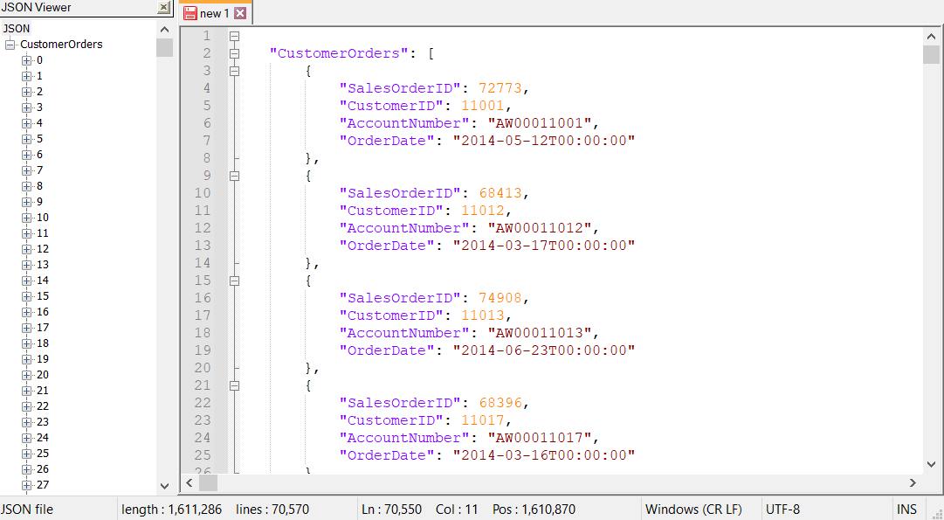

# Proposition 02 – Find all customers who have not placed orders

Explanation: Using the salesorderid and customer id to find matching orders and include customers with no orders

## Columns from Standard view



## Columns from key view



## Columns from their respective tables in the select clause

|  |  |
| --- | --- |
| Table Name | Column Name |
| Customer | OrderDate  CustomerId |
| SalesOrderHeader | SalesOrderID |

## Problem solving Query

USE AdventureWorks2017;

SELECT C.CustomerID,

S.SalesOrderID,

S.OrderDate

FROM Sales.Customer AS C

LEFT OUTER JOIN Sales.SalesOrderHeader AS S

ON C.CustomerID = S.CustomerID

WHERE S.SalesOrderID IS NULL;

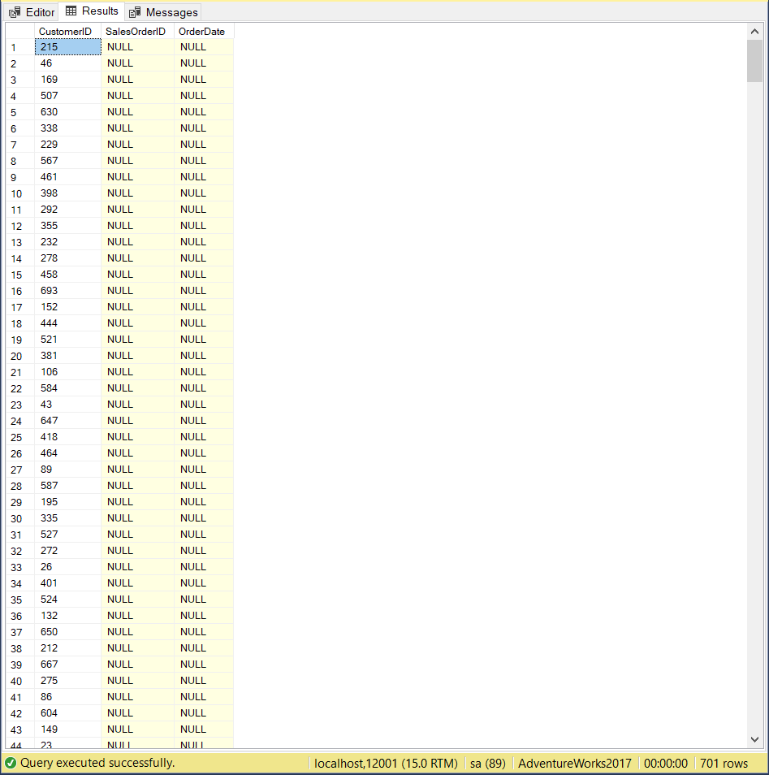

## Sample JSON Output with total number of rows returned(701)

USE AdventureWorks2017;

SELECT C.CustomerID,

S.SalesOrderID,

S.OrderDate

FROM Sales.Customer AS C

LEFT OUTER JOIN Sales.SalesOrderHeader AS S

ON C.CustomerID = S.CustomerID

WHERE S.SalesOrderID IS NULL

FOR JSON PATH, ROOT('NoOrders'), INCLUDE_NULL_VALUES;

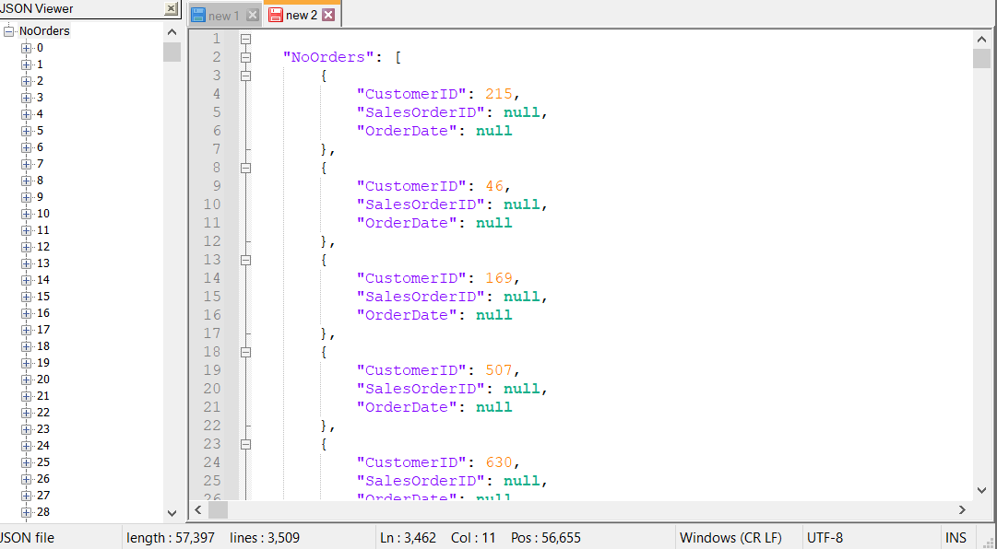

# Proposition 03: Find all sales territories that have an IP Address beginning with “192”

Explanation: Find locations based on sales territories that have ip addresses beginning with '192' and include the locations country, city, state/province code, state/province name, country/region code and postal code

## Columns From Standard view



## Columns From Key View



## Columns from their respective table in the select clause

|  |  |
| --- | --- |
| Table Name | Column Name |
| DimSalesTerritory | SalesTerritoryCountry |
| DimGeography | City  StateProvinceCode  StateProvinceName  CountryRegionCode  PostalCode  IpAddressLocator |

## Problem Solving Query

USE AdventureWorksDW2017;

SELECT T.SalesTerritoryCountry,

G.City,

G.StateProvinceCode,

G.StateProvinceName,

G.CountryRegionCode,

G.PostalCode,

G.IpAddressLocator

FROM dbo.DimSalesTerritory AS T

INNER JOIN dbo.DimGeography AS G

ON G.SalesTerritoryKey = T.SalesTerritoryKey

WHERE G.IpAddressLocator LIKE '192%';

## Sample Relational Output with total number of rows returned (254)

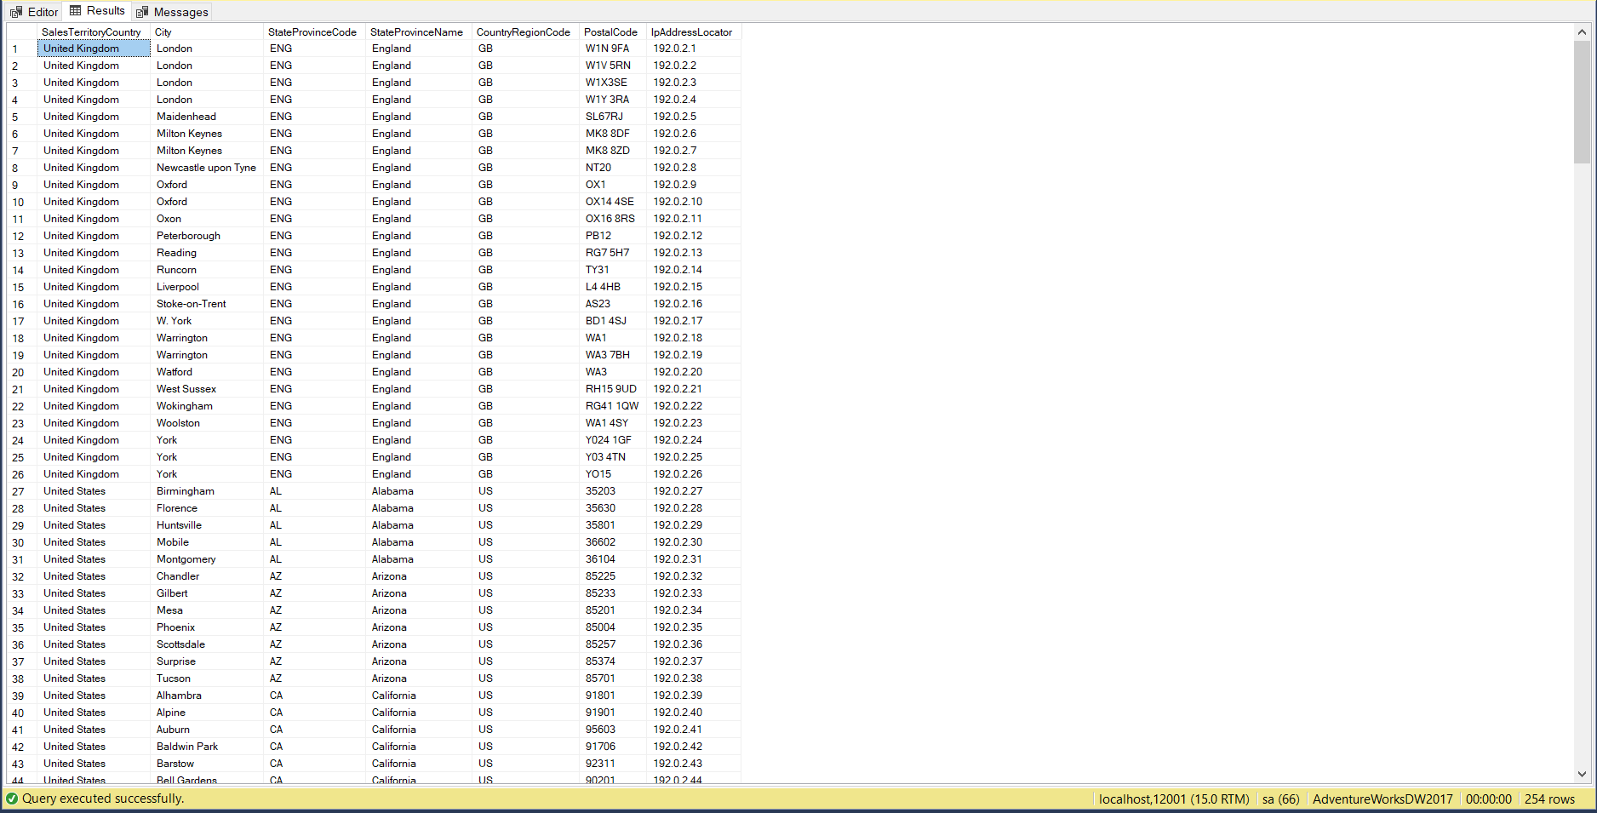

## Sample JSON Output with total number of rows (254)

USE AdventureWorksDW2017;

SELECT T.SalesTerritoryCountry,

G.City,

G.StateProvinceCode,

G.StateProvinceName,

G.CountryRegionCode,

G.PostalCode,

G.IpAddressLocator

FROM dbo.DimSalesTerritory AS T

INNER JOIN dbo.DimGeography AS G

ON G.SalesTerritoryKey = T.SalesTerritoryKey

WHERE G.IpAddressLocator LIKE '192%'

FOR JSON PATH, ROOT('IpAddress'), INCLUDE_NULL_VALUES;

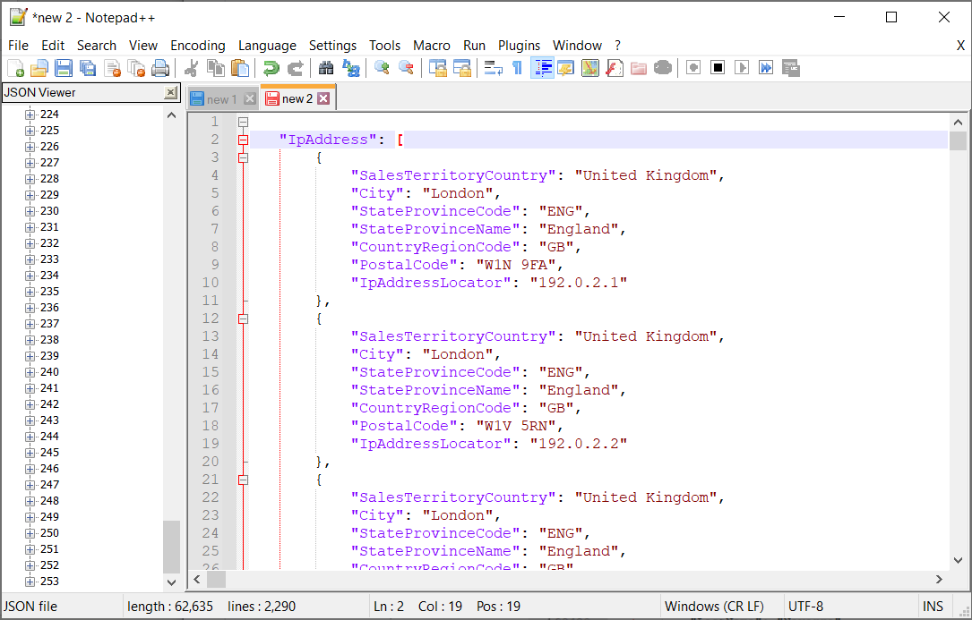

# Proposition 04: Find all customers who placed their first purchase in 2014 and have a postal code that starts with a letter

Explanation: Find information about customers who placed their first purchase during the year of 2014, who have a postal code that starts with a letter and include the customerkey, geography key, date of first purchase, Email address, phone number, address, postal country and country

## Columns from Standard View



## Columns from Key View



## Column from their respective table in the select clause

|  |  |
| --- | --- |
| Table Name | Column Name |
| DimCustomer | CustomerKey  GeographyKey  FirstName  LastName  EmailAddress  Phone  AddressLine1 |
| DimGeography | StateProvinceCode  StateProvinceName  CountryRegionCode  PostalCode  IpAddressLocator |

# Order By

|  |  |  |
| --- | --- | --- |
| Table Name | Column Name | Sort |
| DimGeography | EnglishCountryRegionName | Default |
| DimCustomer | CustomerKey | Default |

## Problem Solving Query

USE AdventureWorksDW2017;

SELECT C.CustomerKey,

C.GeographyKey,

CONCAT_WS(',', C.FirstName, C.LastName) AS custname,

(C.DateFirstPurchase) AS FirstPurchase,

C.EmailAddress,

C.Phone,

CONCAT_WS(' ,', C.AddressLine1, G.City, G.StateProvinceCode, G.StateProvinceName) AS Address,

G.PostalCode AS ZipCode,

G.EnglishCountryRegionName AS country

FROM dbo.DimCustomer AS C

INNER JOIN dbo.DimGeography AS G

ON G.GeographyKey = C.GeographyKey

WHERE YEAR(C.DateFirstPurchase) = 2014

AND G.PostalCode LIKE '[A-Z]%'

ORDER BY G. EnglishCountryRegionName,

C.CustomerKey;

## Sample Relational output with total number of rows returned (65)

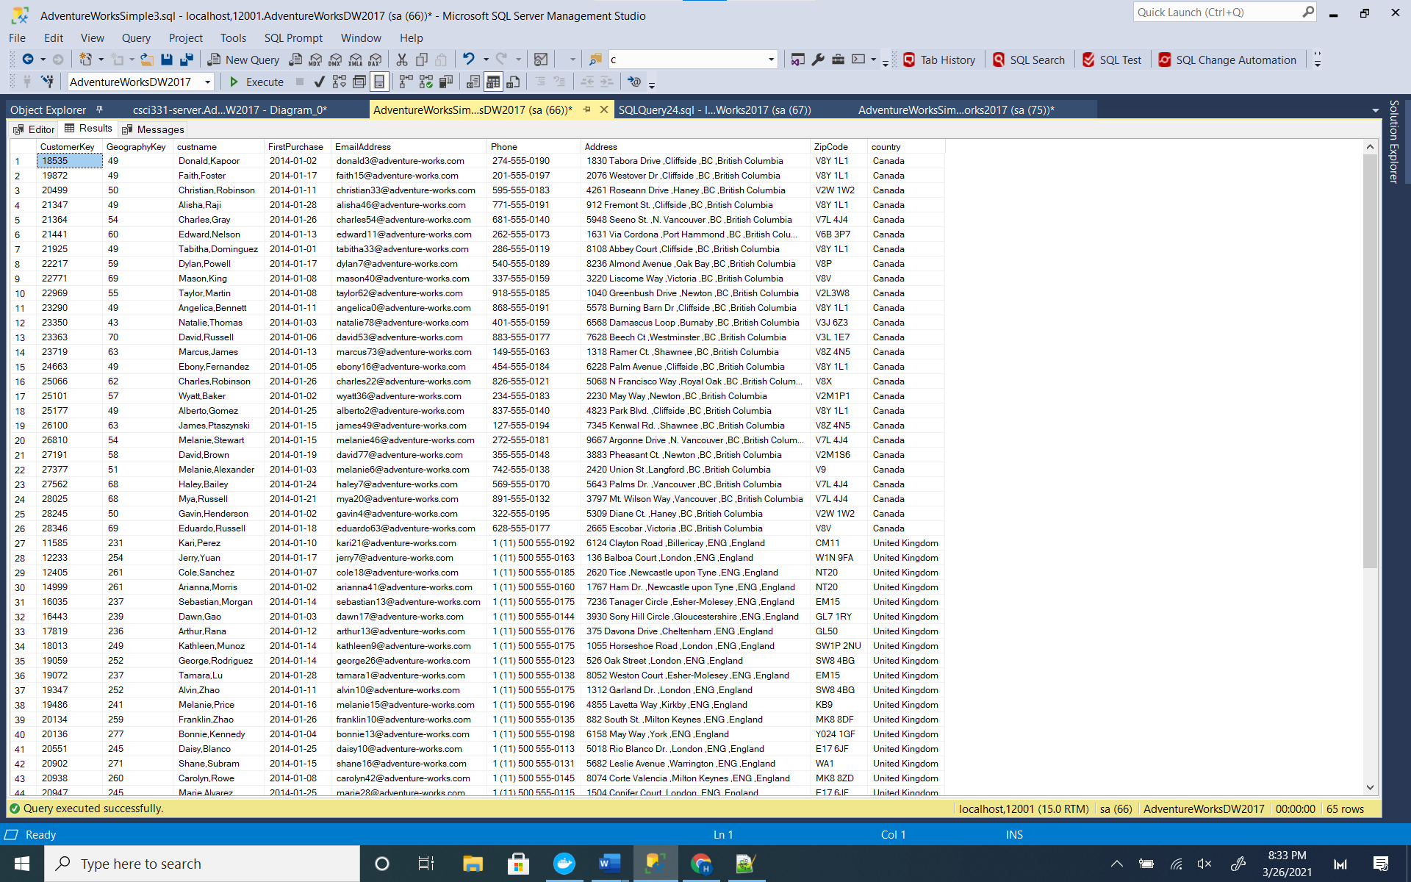

## Sample Json Output With Total number of rows returned (65)

SELECT C.CustomerKey,

C.GeographyKey,

CONCAT_WS(',', C.FirstName, C.LastName) AS custname,

(C.DateFirstPurchase) AS FirstPurchase,

C.EmailAddress,

C.Phone,

CONCAT_WS(' ,', C.AddressLine1, G.City, G.StateProvinceCode, G.StateProvinceName) AS Address,

G.PostalCode AS ZipCode,

G.EnglishCountryRegionName AS country

FROM dbo.DimCustomer AS C

INNER JOIN dbo.DimGeography AS G

ON G.GeographyKey = C.GeographyKey

WHERE YEAR(C.DateFirstPurchase) = 2014

AND G.PostalCode LIKE '[A-Z]%'

ORDER BY G.EnglishCountryRegionName,

C.CustomerKey

FOR JSON PATH,ROOT('CustomerLocation'),INCLUDE_NULL_VALUES;

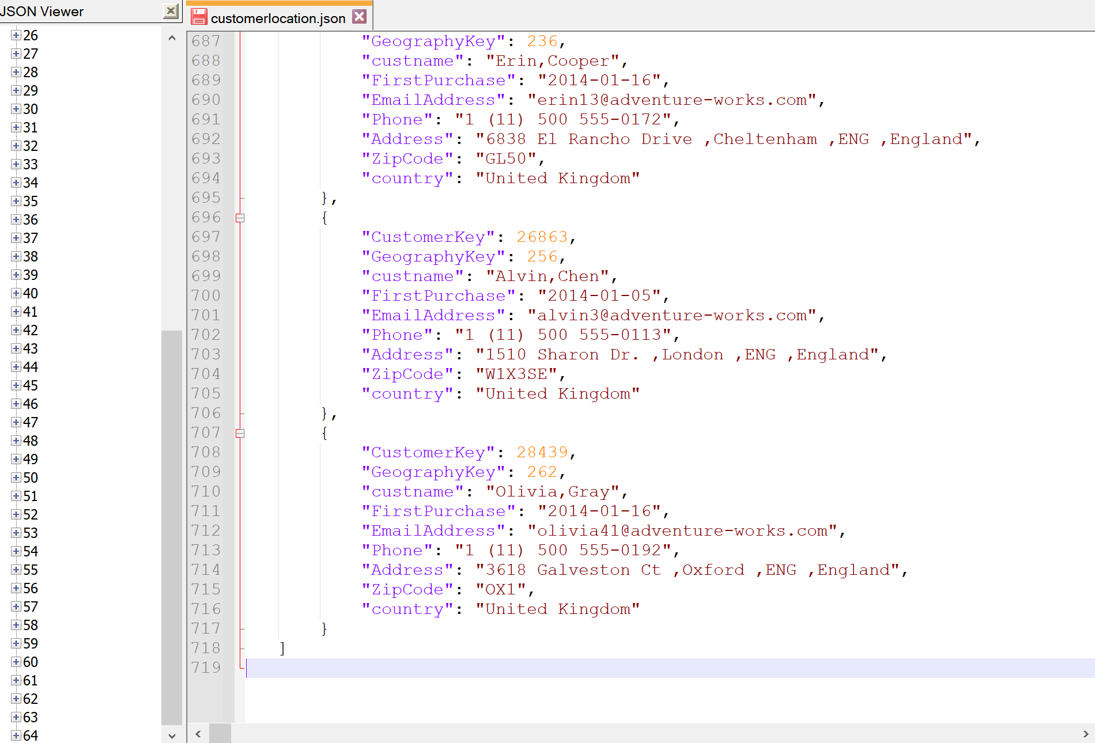

# Proposition 05: Figure out customer loyalty level

Explanation: Assign loyalty levels to customers based on the amount of orders they placed beginning with the most amount of orders being Platinum level then Gold, Silver and Bronzeas decreasing levels

## Columns from Standard View



## Columns from Key View



## Columns from their respective table in the select clause

|  |  |
| --- | --- |
| Table Name | Column Name |
| Order | OrderId |
| Customer | CustomerId  CustomerContactName |
| DerivedColumn | LoyaltyLevel |

## Order By

|  |  |  |
| --- | --- | --- |
| Table Name | Column Name | Sort Order |
| Order | OrderId | DESC |

## Problem Solving Query

USE Northwinds2020TSQLV6;

SELECT DISTINCT

C.CustomerId,

C.CustomerContactName,

COUNT(O.OrderId) AS Orders,

"LoyaltyLevel" = CASE

WHEN COUNT(O.OrderId) >= 30 THEN

'Platinum'

WHEN COUNT(O.OrderId) < 30

AND COUNT(O.OrderId) >= 20 THEN

'Gold'

WHEN COUNT(O.OrderId) < 20

AND COUNT(O.OrderId) >= 10 THEN

'Silver'

WHEN COUNT(O.OrderId) < 10 THEN

' Bronze'

END

FROM Sales.[Order] AS O

INNER JOIN Sales.Customer AS C

ON C.CustomerId = O.CustomerId

GROUP BY C.CustomerId,

C.CustomerContactName

ORDER BY Orders DESC;

--FOR JSON PATH, ROOT('Loyalty'), INCLUDE_NULL_VALUES;

## Sample Relational output with total number of rows returned (89)

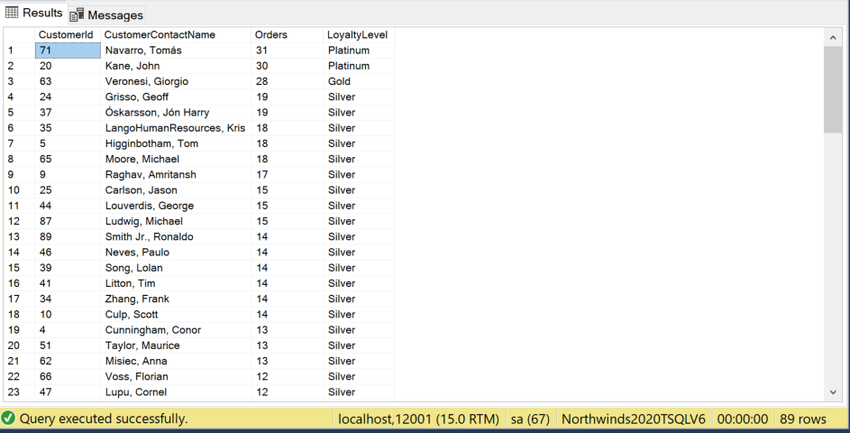

## Sample JSON output with total number of rows returned(89)

USE Northwinds2020TSQLV6;

SELECT DISTINCT

C.CustomerId,

C.CustomerContactName,

COUNT(O.OrderId) AS Orders,

"LoyaltyLevel" = CASE

WHEN COUNT(O.OrderId) >= 30 THEN

'Platinum'

WHEN COUNT(O.OrderId) < 30

AND COUNT(O.OrderId) >= 20 THEN

'Gold'

WHEN COUNT(O.OrderId) < 20

AND COUNT(O.OrderId) >= 10 THEN

'Silver'

WHEN COUNT(O.OrderId) < 10 THEN

' Bronze'

END

FROM Sales.[Order] AS O

INNER JOIN Sales.Customer AS C

ON C.CustomerId = O.CustomerId

GROUP BY C.CustomerId,

C.CustomerContactName

ORDER BY Orders DESC

FOR JSON PATH, ROOT('Loyalty'), INCLUDE_NULL_VALUES;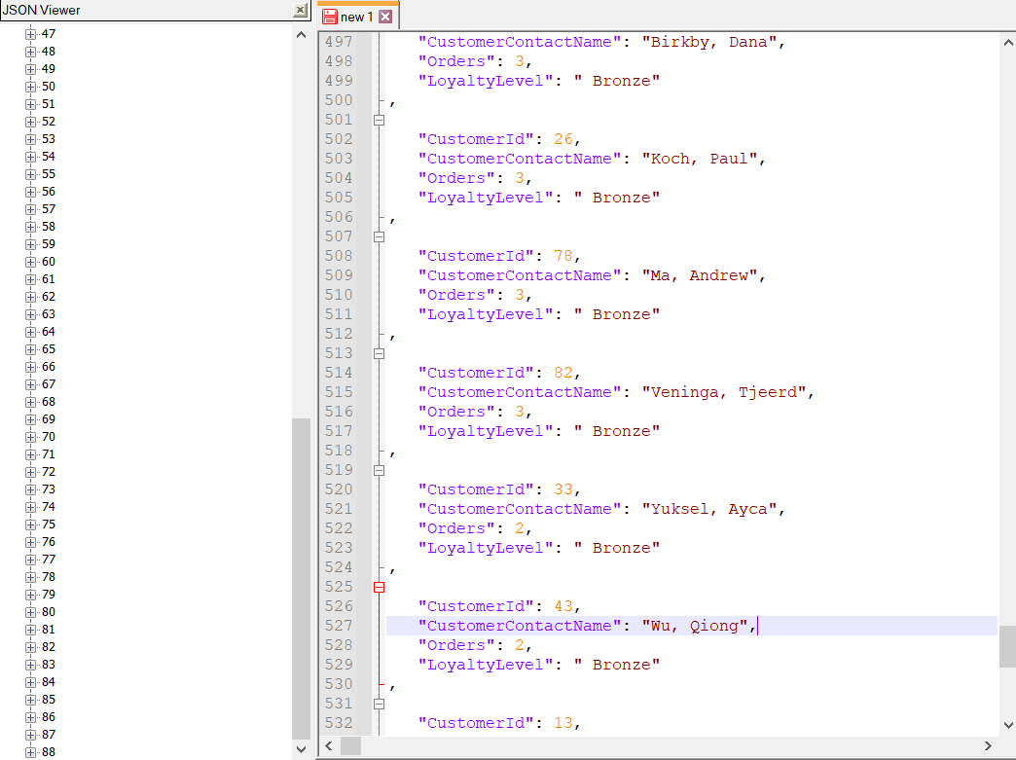

# Proposition 06: Find the amount of orders shipped by each shipping company based on the country they shipped and limit the results to shipments of amounts greater than 10

## Columns from Standard View



## Columns from Key View



## Columns from their respective table in the select clause

|  |  |
| --- | --- |
| Table Name | Column Name |
| Shipper | ShipperCompanyName |
| Order | ShipToCountry |
| DerivedColumn | AmtShippedToCountry |

## Order by

|  |  |  |
| --- | --- | --- |
| Table Name | Column Name | Sort |
| Order | ShipToCountry | DESC |

## Problem Solving Query

USE Northwinds2020TSQLV6;

SELECT S.ShipperCompanyName,

COUNT(*) AS AmtShippedToCountry,

O.ShipToCountry AS Countries

FROM Sales.Shipper AS S

INNER JOIN Sales.[Order] AS O

ON O.ShipperId = S.ShipperId

GROUP BY S.ShipperCompanyName,

O.ShipToCountry

HAVING COUNT(*) > 10

ORDER BY AmtShippedToCountry DESC;

## Sample Relational output with total number of rows returned (26)

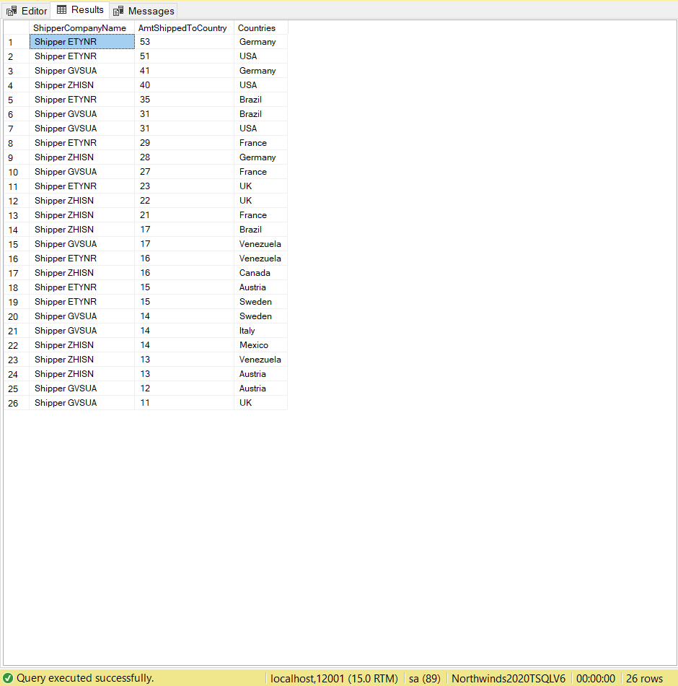

## Sample JSON output with total number of rows returned(26)

USE Northwinds2020TSQLV6;

SELECT S.ShipperCompanyName,

COUNT(*) AS AmtShippedToCountry,

O.ShipToCountry AS Countries

FROM Sales.Shipper AS S

INNER JOIN Sales.[Order] AS O

ON O.ShipperId = S.ShipperId

GROUP BY S.ShipperCompanyName,

O.ShipToCountry

HAVING COUNT(*) > 10

ORDER BY AmtShippedToCountry DESC

FOR JSON PATH, ROOT('TopShipperCountries'), INCLUDE_NULL_VALUES;

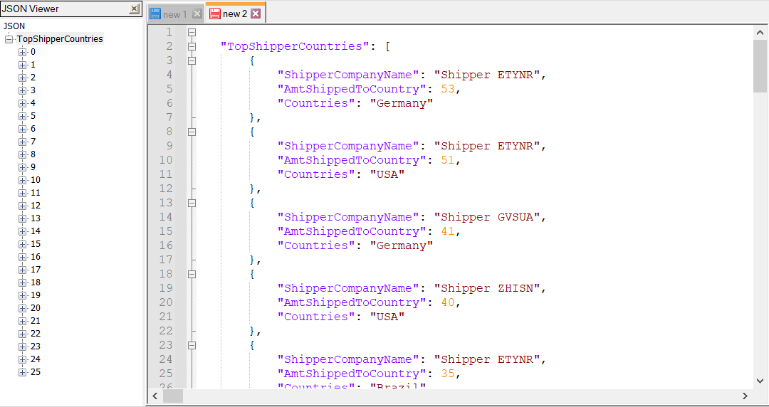

# Proposition 07: Find all the top 10 percent products that had the longest deviation in time from the scheduled start date compared to the actual start date and the scheduled end date compared to the actual end date as well as the process in assembly where the deviation occurred.

Explanation: During the production phases of all products, which products were in the top 10 percent for having the longest difference in time between their scheduled start date and actual-start date and the longest difference in time between their scheduled end date and which sequence of production were they in

## Columns from Standard View



## Columns from Key View



## Columns from their respective table in the select clause

|  |  |
| --- | --- |
| Table Name | Column Name |
| WorkOrderRouting | WorkOrderId  OperationSequence  ScheduledStartDate  ActualStartDate  ScheduledEndDate  WOR.ActualEndDate) |
| Product | Name |
| Location | Name |
| DerivedColumn | ScheduledVsActualStartDate  ScheduledVsActualEndDate |

## Order By

|  |  |  |
| --- | --- | --- |
| Table Name | Column Name | Sort |
| WorkOrderRouting | ScheduledVSActualEndDate  OperationSequence | DESC |
| Product | Name | Default |

## Problem Solving Query

USE AdventureWorks2017;

SELECT TOP (10) PERCENT

WOR.WorkOrderID,

P.Name AS ProductName,

L.Name AS OperationLocation,

WOR.OperationSequence,

DATEDIFF(dd, WOR.ScheduledStartDate, WOR.ActualStartDate) AS ScheduledVSActualStartDate,

DATEDIFF(dd, WOR.ScheduledEndDate, WOR.ActualEndDate) AS ScheduledVSActualEndDate

FROM Production.WorkOrderRouting AS WOR

INNER JOIN Production.Location AS L

ON L.LocationID = WOR.LocationID

INNER JOIN Production.Product AS P

ON P.ProductID = WOR.ProductID

WHERE DATEDIFF(dd, WOR.ScheduledStartDate, WOR.ActualStartDate) > 0

AND DATEDIFF(dd, WOR.ScheduledEndDate, WOR.ActualEndDate) > 0

GROUP BY DATEDIFF(dd, WOR.ScheduledStartDate, WOR.ActualStartDate),

DATEDIFF(dd, WOR.ScheduledEndDate, WOR.ActualEndDate),

WOR.WorkOrderID,

P.Name,

L.Name,

WOR.OperationSequence

ORDER BY ScheduledVSActualEndDate DESC,

WOR.OperationSequence,

P.Name;

## Sample Relational output with total number of rows returned(1103)

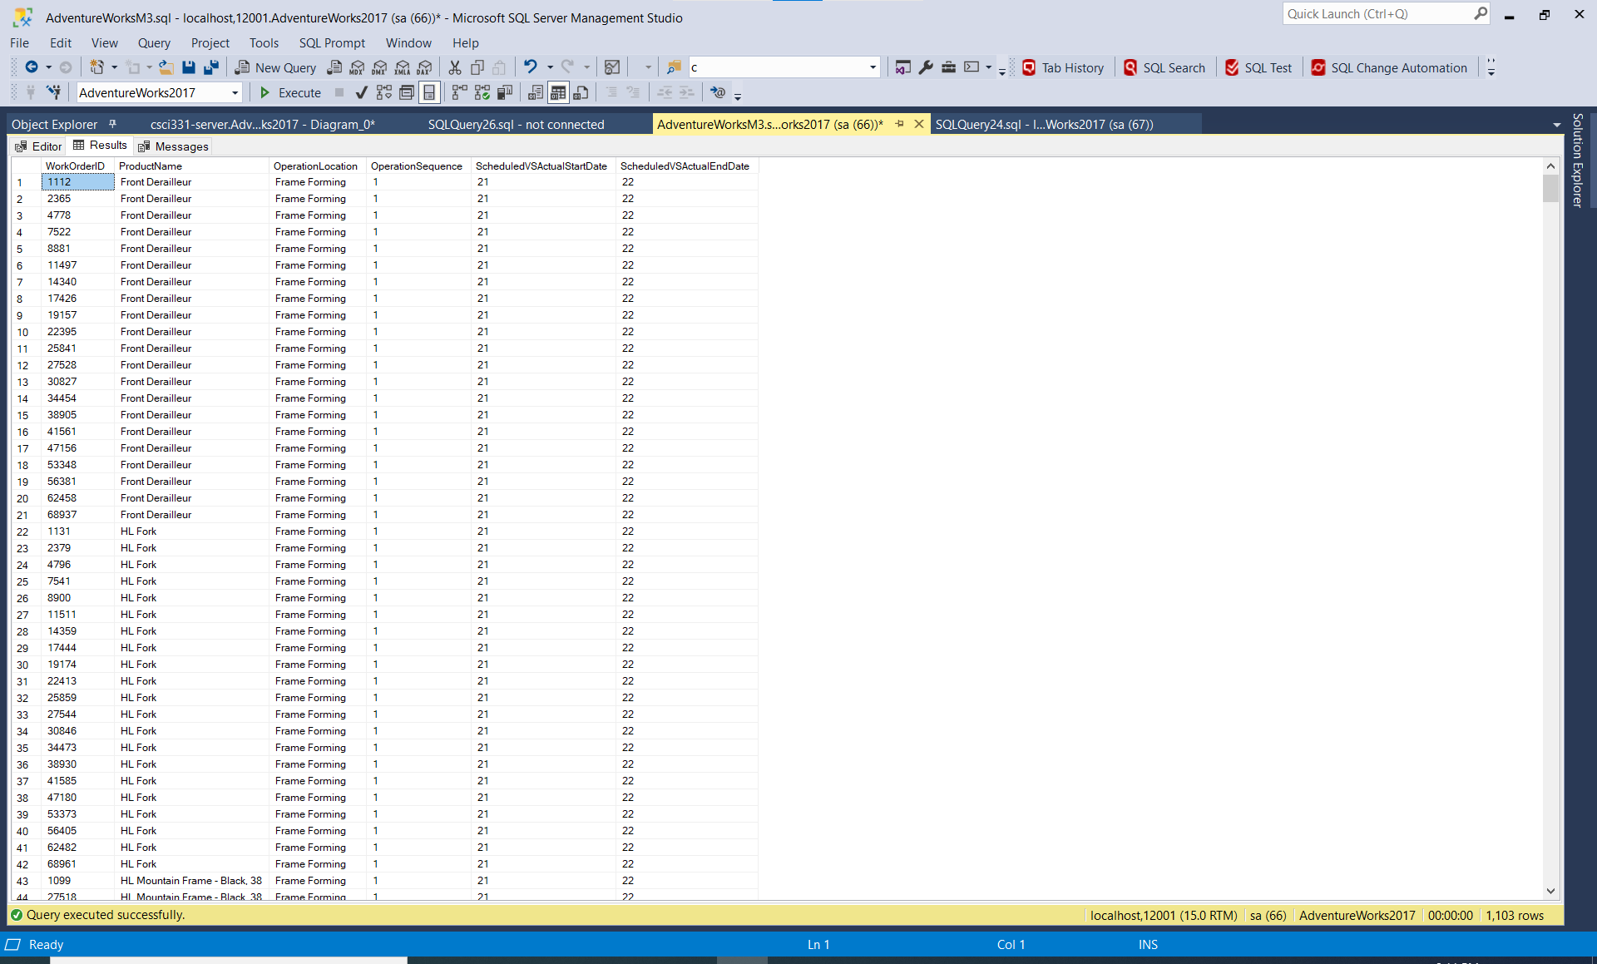

## Sample JSON output with total number of rows returned(1103)

USE AdventureWorks2017;

SELECT TOP (10) PERCENT

WOR.WorkOrderID,

P.Name AS ProductName,

L.Name AS OperationLocation,

WOR.OperationSequence,

DATEDIFF(dd, WOR.ScheduledStartDate, WOR.ActualStartDate) AS ScheduledVSActualStartDate,

DATEDIFF(dd, WOR.ScheduledEndDate, WOR.ActualEndDate) AS ScheduledVSActualEndDate

FROM Production.WorkOrderRouting AS WOR

INNER JOIN Production.Location AS L

ON L.LocationID = WOR.LocationID

INNER JOIN Production.Product AS P

ON P.ProductID = WOR.ProductID

WHERE DATEDIFF(dd, WOR.ScheduledStartDate, WOR.ActualStartDate) > 0

AND DATEDIFF(dd, WOR.ScheduledEndDate, WOR.ActualEndDate) > 0

GROUP BY DATEDIFF(dd, WOR.ScheduledStartDate, WOR.ActualStartDate),

DATEDIFF(dd, WOR.ScheduledEndDate, WOR.ActualEndDate),

WOR.WorkOrderID,

P.Name,

L.Name,

WOR.OperationSequence

ORDER BY ScheduledVSActualEndDate DESC,

WOR.OperationSequence,

P.Name

FOR JSON PATH, ROOT('ProductionTime'),INCLUDE_NULL_VALUES

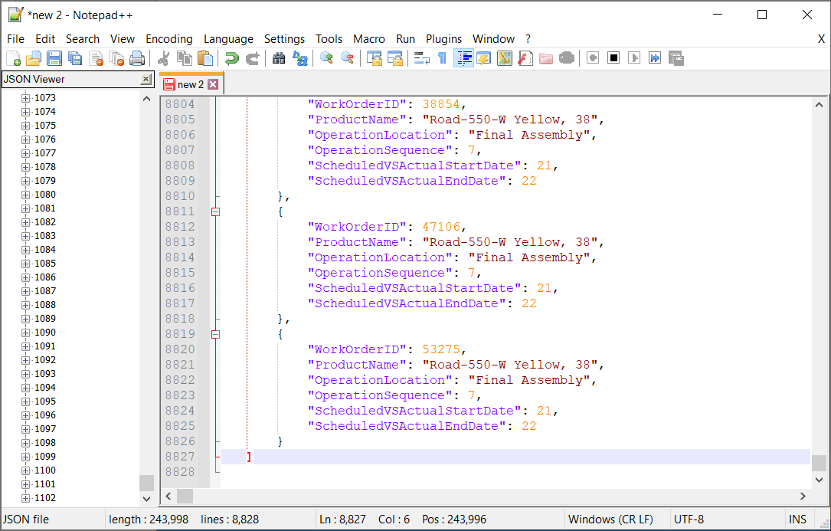

# Proposition 08: Find the total salary for each employee based on their pay frequency, commission percentage, pay rate, and bonus as well as their sales location.

Explanation: Find all the sales representatives by their sales territory and the country return their base rate pay, pay frequency(whether they were payed biweekly or had a salary), and calculate their total salary based on their base rate pay, pay frequency, commission percent, and bonus

## Columns from Standard View



## Columns from Key View



## Columns from their respective table in the select clause

|  |  |
| --- | --- |
| Table Name | Column Name |
| Employee | JobTitle |
| Territory | Name  CountryRegionCode |
| Person | FirstName  MiddleName  LastName |
| EmployeePayHistory | Rate |
| SalesPerson | CommissionPct  SalesYTD  Bonus |
| DerivedColumn | PayFrequency(Case statement)  TotalSalary |

## Order By

|  |  |  |
| --- | --- | --- |
| Table Name | Column Name | Sort |
| DerivedColumn | TotalSalary | DESC |

## Problem solving Query

USE AdventureWorks2017;

SELECT Territory.Name,

Territory.CountryRegionCode,

E.JobTitle,

CONCAT_WS(', ', P.FirstName, P.MiddleName, P.LastName) AS SalesPersonName,

pay.Rate,

"PayFrequency" = CASE

WHEN pay.PayFrequency = 1 THEN

'Salary'

ELSE

'BiWeekly'

END,

((SP.CommissionPct * SP.SalesYTD) + (pay.Rate * 40 * 14) * 26 + SP.Bonus) AS TotalSalary

FROM HumanResources.Employee AS E

RIGHT OUTER JOIN Sales.SalesPerson AS SP

ON E.BusinessEntityID = SP.BusinessEntityID

INNER JOIN Person.Person AS P

ON P.BusinessEntityID = E.BusinessEntityID

INNER JOIN Sales.SalesTerritory AS Territory

ON Territory.TerritoryID = SP.TerritoryID

INNER JOIN HumanResources.EmployeePayHistory AS pay

ON pay.BusinessEntityID = E.BusinessEntityID

GROUP BY CONCAT_WS(', ', P.FirstName, P.MiddleName, P.LastName),

CASE

WHEN pay.PayFrequency = 1 THEN

'Salary'

ELSE

'BiWeekly'

END,

((SP.CommissionPct * SP.SalesYTD) + (pay.Rate * 40 * 14) * 26 + SP.Bonus),

Territory.Name,

Territory.CountryRegionCode,

E.JobTitle,

pay.Rate

ORDER BY TotalSalary DESC;

## Sample Relational output with total number of rows returned(14)

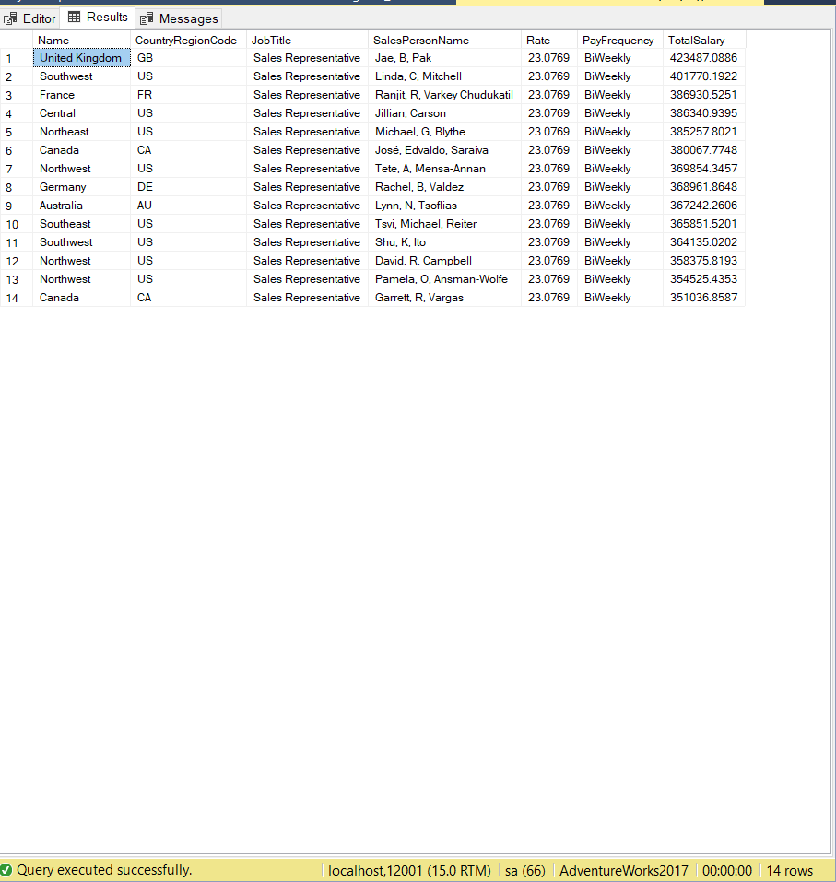

## Sample JSON output with total number of rows returned(14)

USE AdventureWorks2017;

SELECT Territory.Name,

Territory.CountryRegionCode,

E.JobTitle,

CONCAT_WS(', ', P.FirstName, P.MiddleName, P.LastName) AS SalesPersonName,

pay.Rate,

"PayFrequency" = CASE

WHEN pay.PayFrequency = 1 THEN

'Salary'

ELSE

'BiWeekly'

END,

((SP.CommissionPct * SP.SalesYTD) + (pay.Rate * 40 * 14) * 26 + SP.Bonus) AS TotalSalary

FROM HumanResources.Employee AS E

RIGHT OUTER JOIN Sales.SalesPerson AS SP

ON E.BusinessEntityID = SP.BusinessEntityID

INNER JOIN Person.Person AS P

ON P.BusinessEntityID = E.BusinessEntityID

INNER JOIN Sales.SalesTerritory AS Territory

ON Territory.TerritoryID = SP.TerritoryID

INNER JOIN HumanResources.EmployeePayHistory AS pay

ON pay.BusinessEntityID = E.BusinessEntityID

GROUP BY CONCAT_WS(', ', P.FirstName, P.MiddleName, P.LastName),

CASE

WHEN pay.PayFrequency = 1 THEN

'Salary'

ELSE

'BiWeekly'

END,

((SP.CommissionPct * SP.SalesYTD) + (pay.Rate * 40 * 14) * 26 + SP.Bonus),

Territory.Name,

Territory.CountryRegionCode,

E.JobTitle,

pay.Rate

ORDER BY TotalSalary DESC

FOR JSON PATH, ROOT('SalesRepSalary'),INCLUDE_NULL_VALUES;

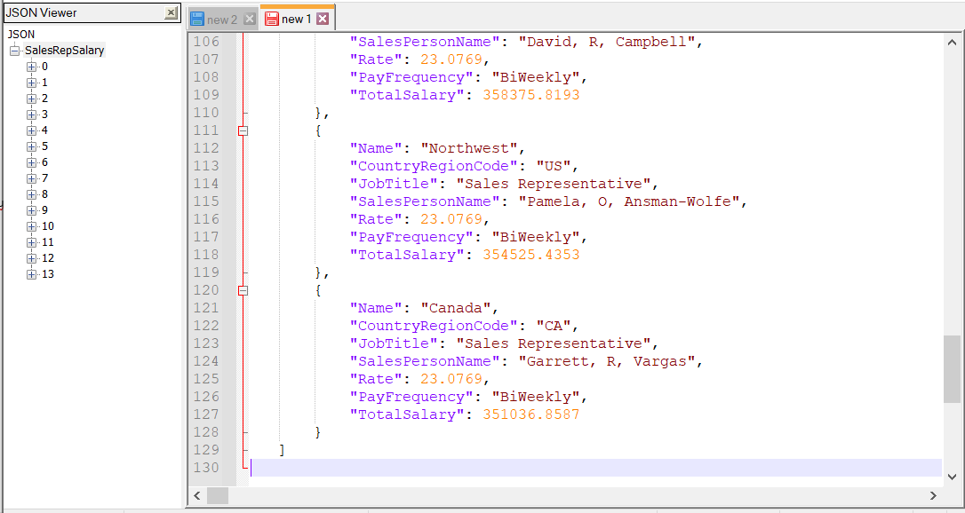

# Proposition 09: Based on the year and month, which products were scrapped, what was the quantity of the products that were scrapped, how much was the total cost of scrapping those products and why were they scrapped?

Explanation: Based on the year and month, which products were scrapped, what was the quantity of the products that were scrapped, how much was the total cost of scrapping those products and why were they scrapped? Standard view

## Columns from Standard View



## Columns from Key View



## Columns from their respective table in the select clause

|  |  |
| --- | --- |
| Table Name | Column Name |
| WorkOrder | EndDate  ProductID  WorkOrderID  ScrappedQty |
| Product | Name  ProductNumber |
| ScrapReason | Name |
| WorkOrderRouting | ActualCost |
| DerivedColumn | TotalScrapCost |

## Order By

|  |  |  |
| --- | --- | --- |
| Table Name | Column Name | Order |
| WorkOrder | YEAR(EndDate) AS ScrapYear  MONTH(EndDate) AS ScrapMonth | Default |
| WorkOrderRouting  Workorder | TotalScrapCost | DESC |

## Problem Solving Query

USE AdventureWorks2017;

SELECT YEAR(WO.EndDate) AS ScrapYear,

MONTH(WO.EndDate) AS ScrapMonth,

WO.ProductID AS ScrappedProductID,

WO.WorkOrderID,

P.Name,

P.ProductNumber,

WO.ScrappedQty,

WOR.ActualCost,

(WO.ScrappedQty) * (WOR.ActualCost) AS TotalScrapCost,

SR.Name AS ScrapReason

FROM Production.WorkOrder AS WO

INNER JOIN Production.Product AS P

ON P.ProductID = WO.ProductID

INNER JOIN Production.ScrapReason AS SR

ON SR.ScrapReasonID = WO.ScrapReasonID

INNER JOIN Production.WorkOrderRouting AS WOR

ON WOR.WorkOrderID = WO.WorkOrderID

WHERE WO.ScrappedQty >= 10

GROUP BY YEAR(WO.EndDate),

MONTH(WO.EndDate),

(WO.ScrappedQty) * (WOR.ActualCost),

WO.ProductID,

WO.WorkOrderID,

P.Name,

P.ProductNumber,

WO.ScrappedQty,

WOR.ActualCost,

SR.Name

ORDER BY ScrapYear,

ScrapMonth,

TotalScrapCost DESC;

## Sample relational out with rows returned (93)

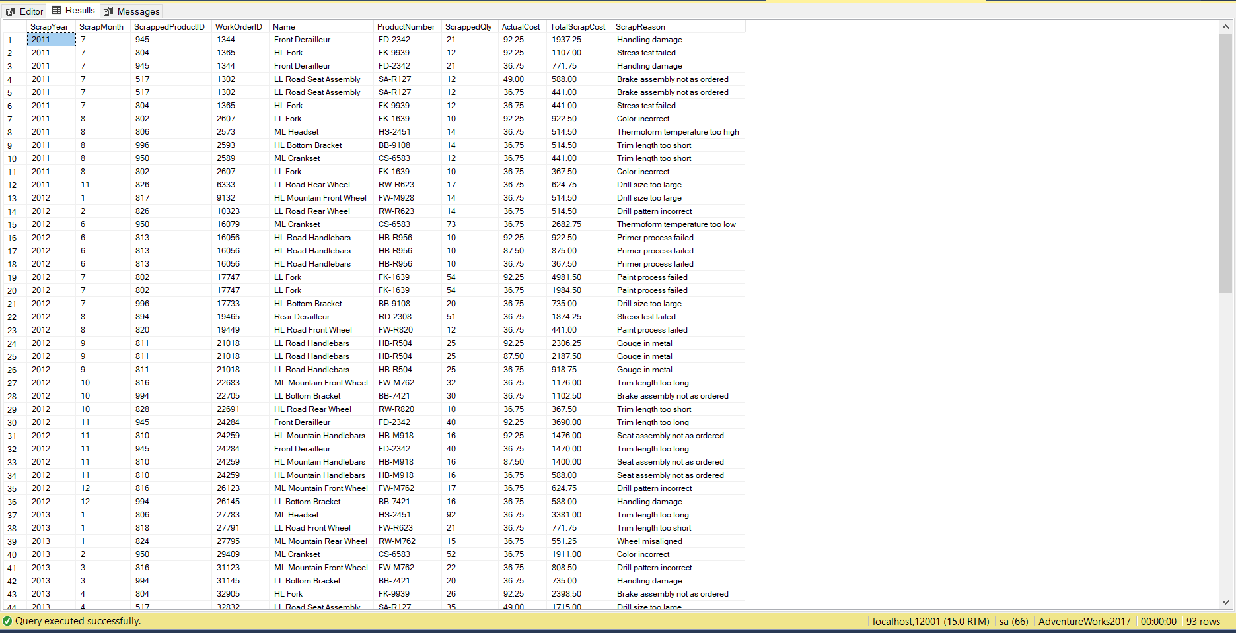

## Sample JSON Output with total number of rows returned(93)

USE AdventureWorks2017;

SELECT YEAR(WO.EndDate) AS ScrapYear,

MONTH(WO.EndDate) AS ScrapMonth,

WO.ProductID AS ScrappedProductID,

WO.WorkOrderID,

P.Name,

P.ProductNumber,

WO.ScrappedQty,

WOR.ActualCost,

(WO.ScrappedQty) * (WOR.ActualCost) AS TotalScrapCost,

SR.Name AS ScrapReason

FROM Production.WorkOrder AS WO

INNER JOIN Production.Product AS P

ON P.ProductID = WO.ProductID

INNER JOIN Production.ScrapReason AS SR

ON SR.ScrapReasonID = WO.ScrapReasonID

INNER JOIN Production.WorkOrderRouting AS WOR

ON WOR.WorkOrderID = WO.WorkOrderID

WHERE WO.ScrappedQty >= 10

GROUP BY YEAR(WO.EndDate),

MONTH(WO.EndDate),

(WO.ScrappedQty) * (WOR.ActualCost),

WO.ProductID,

WO.WorkOrderID,

P.Name,

P.ProductNumber,

WO.ScrappedQty,

WOR.ActualCost,

SR.Name

ORDER BY ScrapYear,

ScrapMonth,

TotalScrapCost DESC

FOR JSON PATH, ROOT('TotalScrapCost'),INCLUDE_NULL_VALUES;

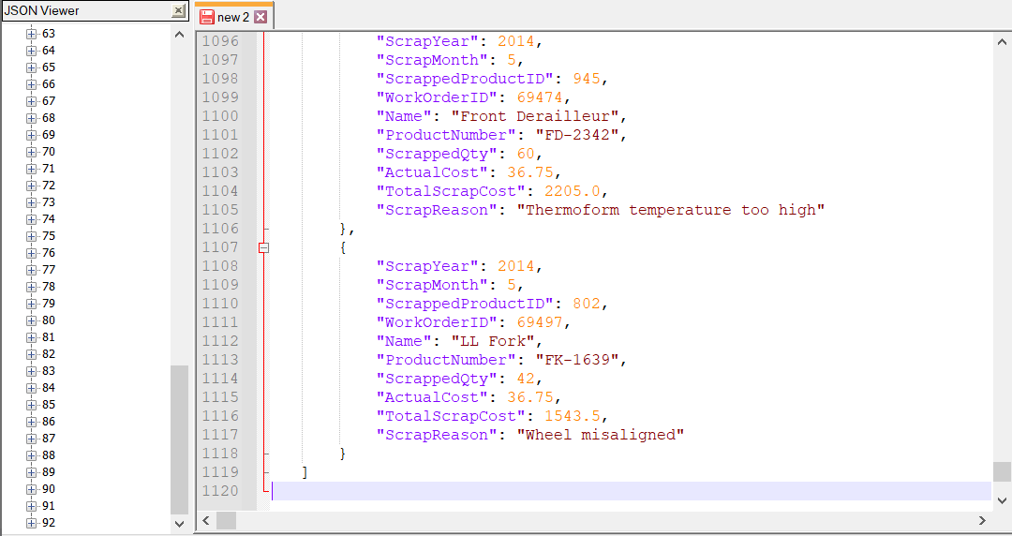

# Proposition 10: What was the growth in territories for each consecutive year, beginning with the first order year, for internet sales?

Explanation: Determine the growth in sales territories for internet sales beginning with the first order year up until the last order year

## Columns from Standard View



## Columns from Key View



## Columns from their respective table in the select clause

|  |  |
| --- | --- |
| Table Name | Column Name |
| FactInternetSales | SalesTerritoryKey  OrderDate |
| DerivedColumn | OrderYear  TerritoryAmt  GrowthInTerritories |

## Problem Solving Query

USE AdventureWorksDW2017;

SELECT C.OrderYear,

C.TerritoryAmt AS CurrentTerritoryAmt,

P.TerritoryAmt AS PreviousTerritoryAmt,

C.TerritoryAmt - P.TerritoryAmt AS GrowthInTerritories

FROM

(

SELECT DATEPART(yyyy, OrderDate) AS OrderYear,

COUNT(DISTINCT SalesTerritoryKey) AS TerritoryAmt

FROM dbo.FactInternetSales

GROUP BY DATEPART(yyyy, OrderDate)

) AS C

LEFT OUTER JOIN

(

SELECT DATEPART(yyyy, OrderDate) AS OrderYear,

COUNT(DISTINCT SalesTerritoryKey) AS TerritoryAmt

FROM dbo.FactInternetSales

GROUP BY DATEPART(yyyy, OrderDate)

) AS P

ON C.OrderYear = P.OrderYear + 1;

## Sample Relational output with total number of rows returned(4)

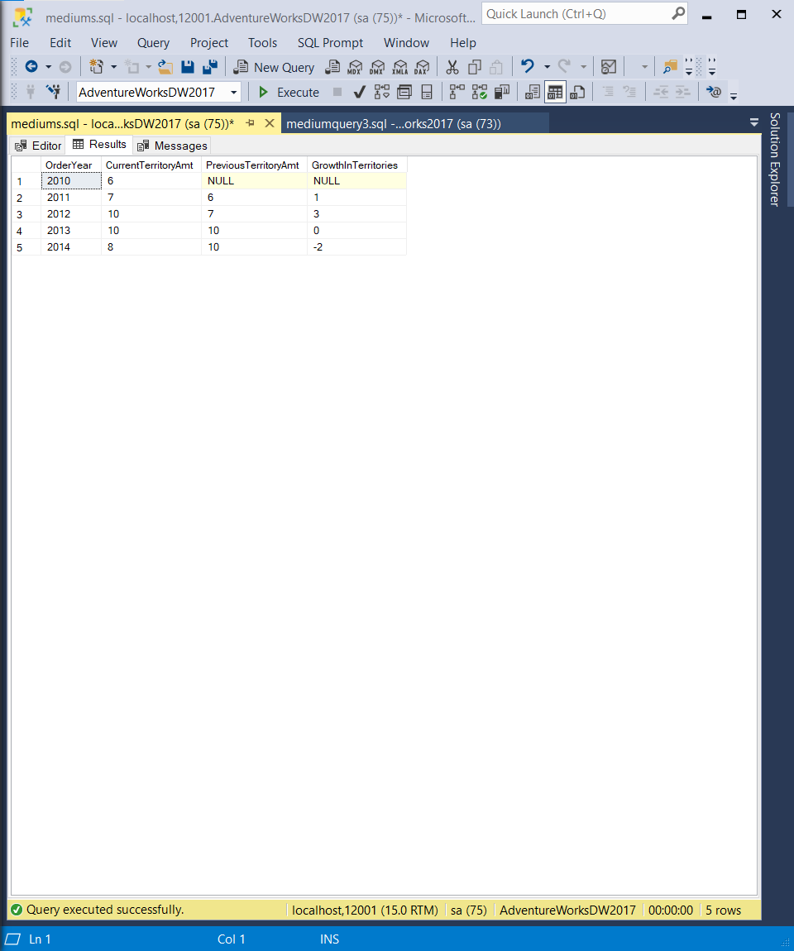

## Sample JSON output with total number of rows returned(4)

USE AdventureWorksDW2017;

SELECT C.OrderYear,

C.TerritoryAmt AS CurrentTerritoryAmt,

P.TerritoryAmt AS PreviousTerritoryAmt,

C.TerritoryAmt - P.TerritoryAmt AS GrowthInTerritories

FROM

(

SELECT DATEPART(yyyy, OrderDate) AS OrderYear,

COUNT(DISTINCT SalesTerritoryKey) AS TerritoryAmt

FROM dbo.FactInternetSales

GROUP BY DATEPART(yyyy, OrderDate)

) AS C

LEFT OUTER JOIN

(

SELECT DATEPART(yyyy, OrderDate) AS OrderYear,

COUNT(DISTINCT SalesTerritoryKey) AS TerritoryAmt

FROM dbo.FactInternetSales

GROUP BY DATEPART(yyyy, OrderDate)

) AS P

ON C.OrderYear = P.OrderYear + 1

FOR JSON PATH, ROOT('TerritoryGrowth'),INCLUDE_NULL_VALUES;

JSON OUTPUT

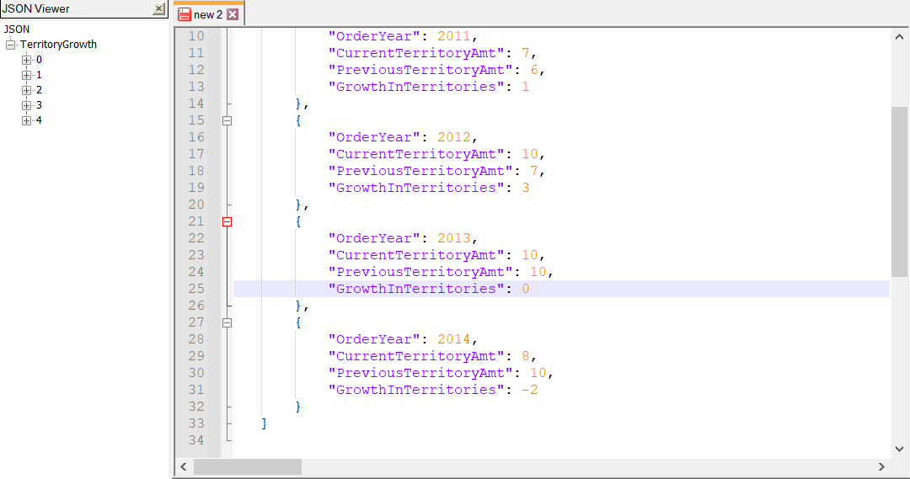

# Proposition 11: Find the total amount of orders placed based upon the sales reason

Explanation: Explanation: Determine the total amount of orders placed based upon the reason of sale for internet sales with the results starting from the top reason

## Columns from Standard View



## Columns from Key View



## Columns from their respective table in the select clause

|  |  |
| --- | --- |
| Table Name | Column Name |
| DimSalesReason | SalesReasonName |
| FactInternetSalesReason | SalesOrderLineNumber |
| DerivedColumn | CountOrders (SalesOrderLineNumber )Count |

## Order By

|  |  |  |
| --- | --- | --- |
| Table Name | Column Name | Sort |
| FactInternetSalesReason | Count(SalesOrderLineNumber)  AS CountOrders | DESC |

## Problem Solving Query

USE AdventureWorksDW2017; SELECT DISTINCT

SR.SalesReasonName,

COUNT(FIS.SalesOrderLineNumber) AS CountOrders

FROM dbo.DimSalesReason AS SR

INNER JOIN dbo.FactInternetSalesReason AS FISR

ON FISR.SalesReasonKey = SR.SalesReasonKey

INNER JOIN dbo.FactInternetSales AS FIS

ON FIS.SalesOrderNumber = FISR.SalesOrderNumber

AND FIS.SalesOrderLineNumber = FISR.SalesOrderLineNumber

WHERE FIS.SalesOrderLineNumber >= 1

GROUP BY SR.SalesReasonName

ORDER BY CountOrders DESC;

## Sample relational output with total number of rows returned(7)

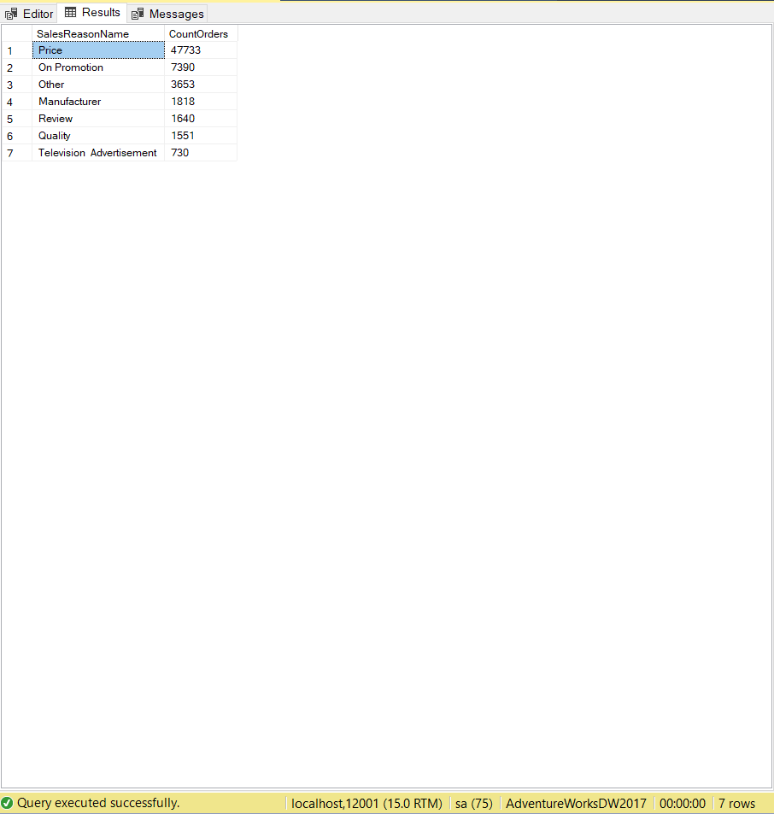

## Sample JSON output with total number of rows returned(7)

USE AdventureWorksDW2017;

SELECT DISTINCT

SR.SalesReasonName,

COUNT(FIS.SalesOrderLineNumber) AS CountOrders

FROM dbo.DimSalesReason AS SR

INNER JOIN dbo.FactInternetSalesReason AS FISR

ON FISR.SalesReasonKey = SR.SalesReasonKey

INNER JOIN dbo.FactInternetSales AS FIS

ON FIS.SalesOrderNumber = FISR.SalesOrderNumber

AND FIS.SalesOrderLineNumber = FISR.SalesOrderLineNumber

WHERE FIS.SalesOrderLineNumber >= 1

GROUP BY SR.SalesReasonName

ORDER BY CountOrders DESC

FOR JSON PATH, ROOT('TotalOrders'), INCLUDE_NULL_VALUES;

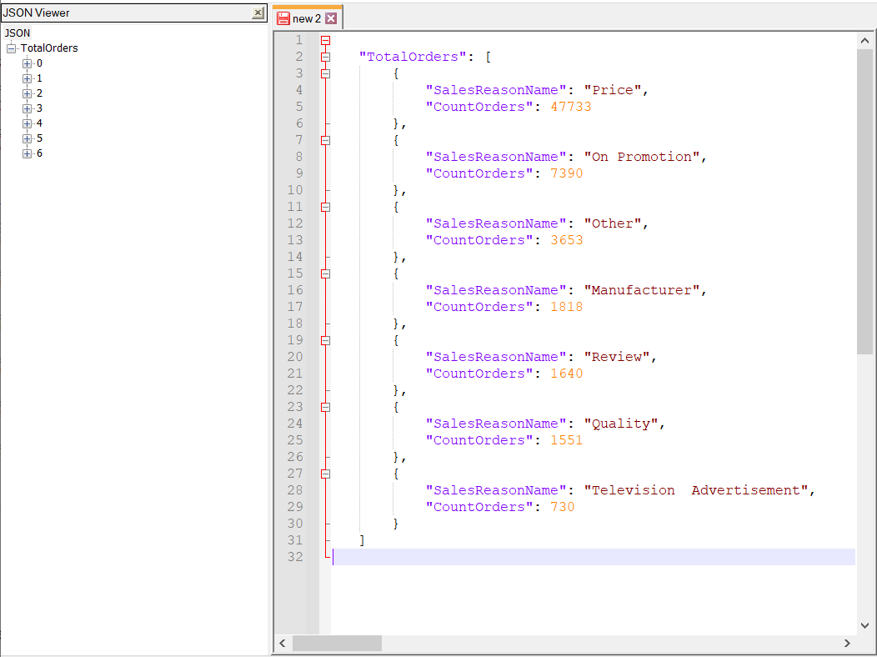

# Proposition 12: Find the total value in sales for each territory

Explanation : Explanation: Calculate the total amount of revenue based on each territory

according to the amount of orders placed, their unit price and discount if applicable

## Columns from Standard View



## Columns from Key View



## Columns from their respective table in the select clause

|  |  |
| --- | --- |
| Table Name | Column Name |
| Customer | TerritoryID |
| SalesOrderDetail | OrderQty  UnitPrice  UnitPriceDiscount |
| DerivedColumn | Total |

## Order by

|  |  |  |
| --- | --- | --- |
| Table Name | Column Name | Sort |
| SalesOrderDetail | Total(OrderQty  UnitPrice  UnitPriceDiscount) | DESC |

## Problem Solving Query

USE AdventureWorks2017;

SELECT C.TerritoryID,

SUM(SOD.OrderQty * SOD.UnitPrice) - SUM((SOD.OrderQty * SOD.UnitPrice) * (1 - SOD.UnitPriceDiscount)) AS Total

FROM Sales.Customer AS C

INNER JOIN Sales.SalesOrderHeader AS O

ON C.CustomerID = O.CustomerID

INNER JOIN Sales.SalesOrderDetail AS SOD

ON O.SalesOrderID = SOD.SalesOrderID

GROUP BY C.TerritoryID

ORDER BY Total DESC;

## Sample Relational Output with total number of rows returned(10)

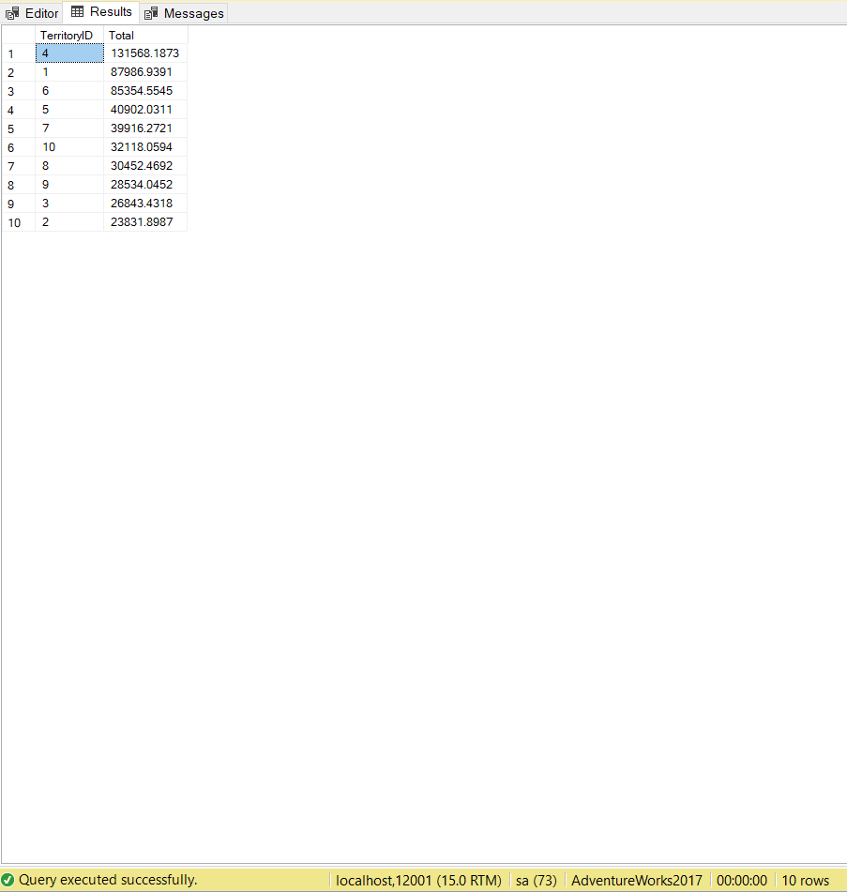

## Sample Relational Output with total number of rows returned(10)

USE AdventureWorks2017;

SELECT C.TerritoryID,

SUM(SOD.OrderQty * SOD.UnitPrice) - SUM((SOD.OrderQty * SOD.UnitPrice) * (1 - SOD.UnitPriceDiscount)) AS Total

FROM Sales.Customer AS C

INNER JOIN Sales.SalesOrderHeader AS O

ON C.CustomerID = O.CustomerID

INNER JOIN Sales.SalesOrderDetail AS SOD

ON O.SalesOrderID = SOD.SalesOrderID

GROUP BY C.TerritoryID

ORDER BY Total DESC

FOR JSON PATH,ROOT('TotalSalesByTerritory'),INCLUDE_NULL_VALUES;

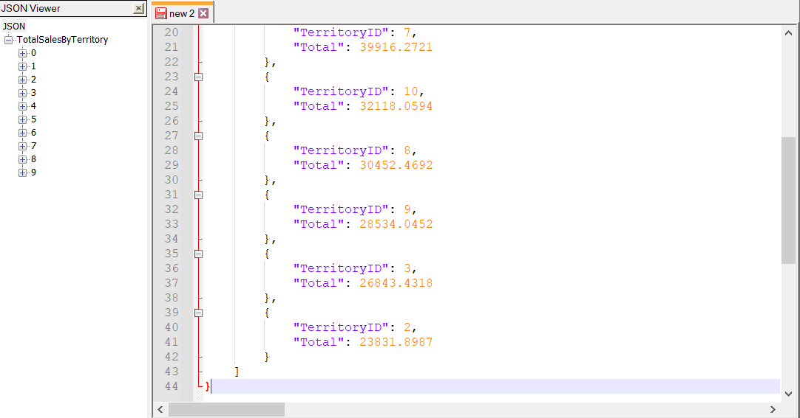

# Proposition 13: Find the amount of orders that were placed based on the color of the product and the age of the customer to determine the preferences of product colors by age

## Columns from Standard View



## Columns from Key View



## Columns from their respective table in the select clause

|  |  |
| --- | --- |
| Table Name | Column Name |
| ProductionListPriceHistory | ListPrice |
| DerivedColumns | MinimumListPrice(MIN function)  MaximumListPrice(MAX function)  AverageListPrice(AVG function)  MaxVsMinDiff(MAX – MIN) |

## Order By

|  |  |  |
| --- | --- | --- |
| Table Name | Column Name | Sort |
| DerivedColumn | MaxVsMinDiff | DESC |

## Problem Solving Query

USE AdventureWorks2017;

SELECT DISTINCT

P.Name AS ProductName,

MIN(PLH.ListPrice) AS MinimumListPrice,

MAX(PLH.ListPrice) AS MaximumListPrice,

AVG(PLH.ListPrice) AS AverageListPrice,

MAX(PLH.ListPrice) - MIN(PLH.ListPrice) AS MaxVsMinDiff

FROM Production.Product AS P

INNER JOIN Production.ProductListPriceHistory AS PLH

ON PLH.ProductID = P.ProductID

GROUP BY P.Name

ORDER BY MaxVsMinDiff DESC;

## Sample Relational output with total number of rows returned(293)

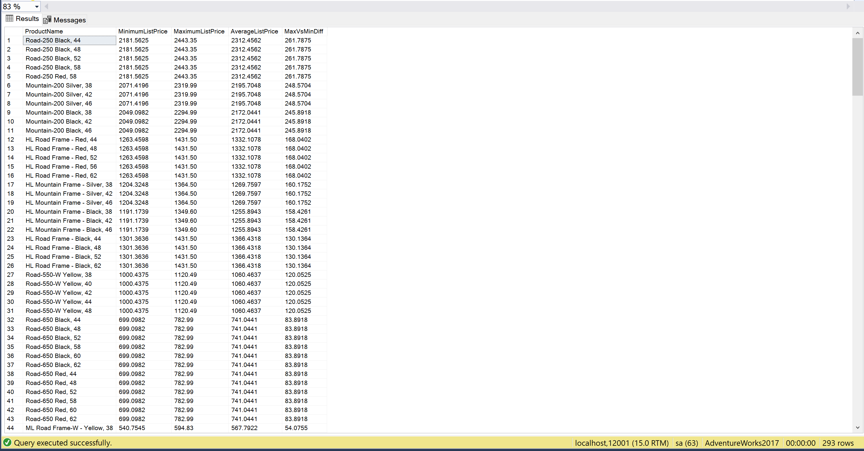

## Sample JSON Output with total number of rows returned(411)

USE AdventureWorks2017;

SELECT DISTINCT

P.Name AS ProductName,

MIN(PLH.ListPrice) AS MinimumListPrice,

MAX(PLH.ListPrice) AS MaximumListPrice,

AVG(PLH.ListPrice) AS AverageListPrice,

MAX(PLH.ListPrice) - MIN(PLH.ListPrice) AS MaxVsMinDiff

FROM Production.Product AS P

INNER JOIN Production.ProductListPriceHistory AS PLH

ON PLH.ProductID = P.ProductID

GROUP BY P.Name

ORDER BY MaxVsMinDiff DESC

FOR JSON PATH,ROOT('ListPriceInfo'),INCLUDE_NULL_VALUES;

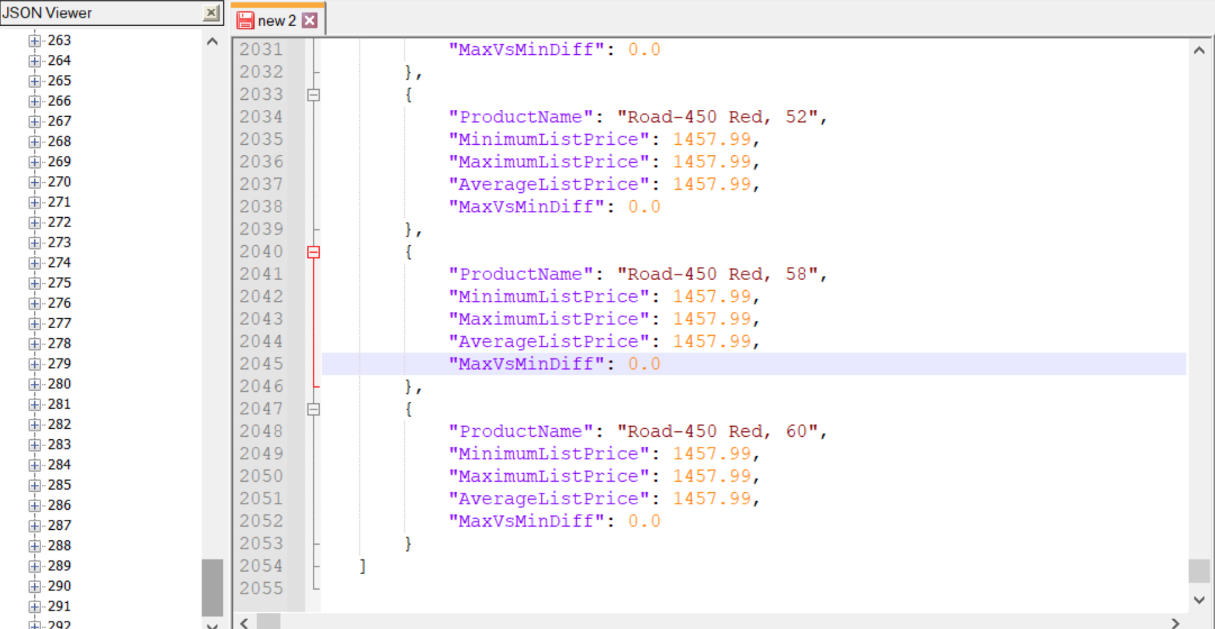

# Proposition 14:

## Columns from Standard View

## Columns from Key View

## Columns from their respective table in the select clause

|  |  |
| --- | --- |
| Table Name | Column Name |
| FactInternetSales | OrderDate |
| DimProduct | Color |
| DimCustomer | BirthDate |
| DerivedColumn | Age  OverallTotalColorsOrdered |

## Order By

|  |  |  |
| --- | --- | --- |
| Table Name | Column Name | Sort |
| Dimproduct | Color | Default |
| DerivedColumn | Age  OverallTotalColorsOrdered | DESC |

## Problem Solving Query

Scalar function --Create a function that returns the age of the customer on the day they placed an order

USE [AdventureWorksDW2017]

GO

SET ANSI_NULLS ON

GO

SET QUOTED_IDENTIFIER ON

GO

DECLARE FUNCTION [dbo].[GetCustomerAgeForOrder]

(

@BirthDate AS DATE,

@OrderDate AS DATETIME

)

RETURNS INT

AS

BEGIN

RETURN DATEDIFF(YEAR, @birthdate, @OrderDate) -

CASE WHEN 100 * MONTH(@OrderDate) + DAY(@OrderDate)

< 100 * MONTH(@birthdate) + DAY(@birthdate)

THEN 1 ELSE 0

END;

END;

USE AdventureWorksDW2017;

SELECT DISTINCT

dbo.GetCustomerAgeForOrder(C.BirthDate, FIS.OrderDate) AS Age,

P.Color,

COUNT(*) OVER (PARTITION BY dbo.GetCustomerAgeForOrder(C.BirthDate, FIS.OrderDate),

P.Color

) OverallTotalOfColorsOrdered

FROM dbo.FactInternetSales AS FIS

INNER JOIN dbo.DimCustomer AS C

ON C.CustomerKey = FIS.CustomerKey

INNER JOIN dbo.DimProduct AS P

ON P.ProductKey = FIS.ProductKey

WHERE P.Color IS NOT NULL

AND P.Color <> 'NA'

GROUP BY dbo.GetCustomerAgeForOrder(C.BirthDate, FIS.OrderDate),

C.CustomerKey,

P.EnglishProductName,

P.Color

ORDER BY Age,

OverallTotalOfColorsOrdered DESC,

P.Color;

## Sample Relational Output with total number of rows returned(411)

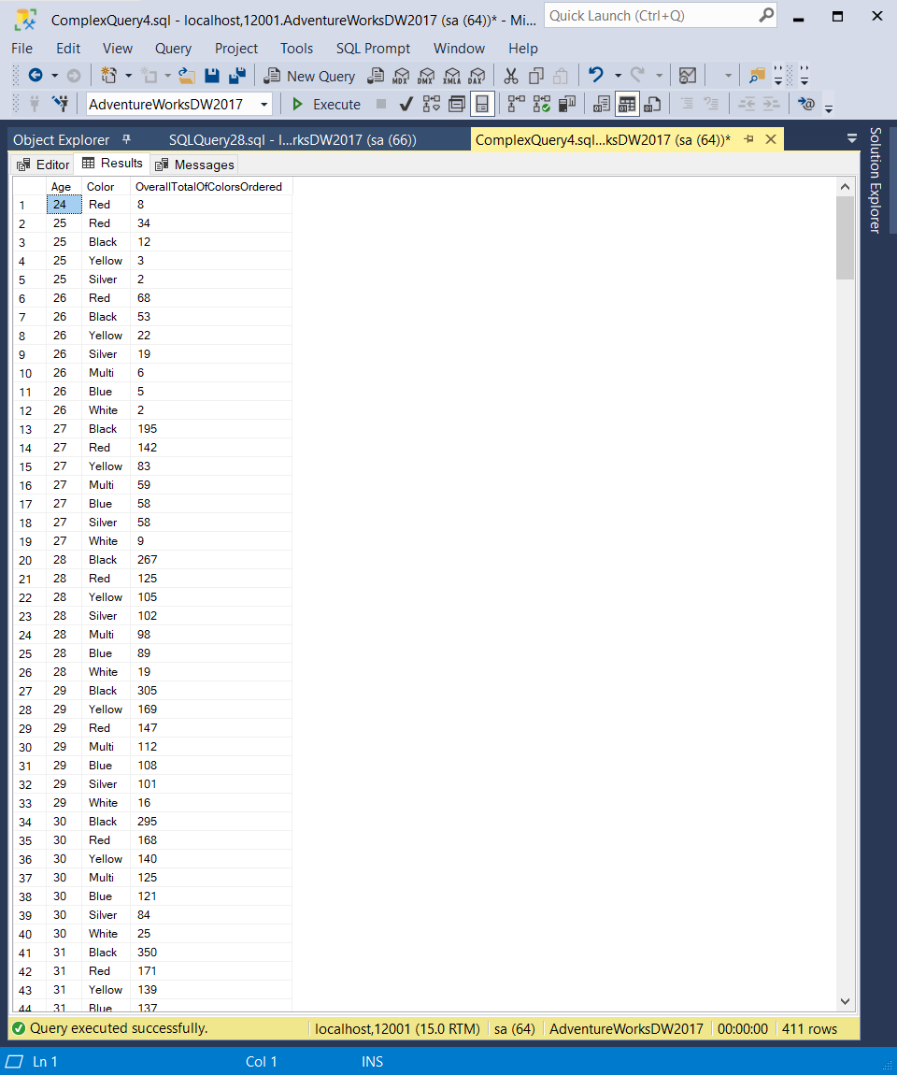

## Sample JSON Output with total number of rows returned(411)

USE AdventureWorksDW2017;

SELECT DISTINCT

dbo.GetCustomerAgeForOrder(C.BirthDate, FIS.OrderDate) AS Age,

P.Color,

COUNT(*) OVER (PARTITION BY dbo.GetCustomerAgeForOrder(C.BirthDate, FIS.OrderDate),

P.Color

) OverallTotalOfColorsOrdered

FROM dbo.FactInternetSales AS FIS

INNER JOIN dbo.DimCustomer AS C

ON C.CustomerKey = FIS.CustomerKey

INNER JOIN dbo.DimProduct AS P

ON P.ProductKey = FIS.ProductKey

WHERE P.Color IS NOT NULL

AND P.Color <> 'NA'

GROUP BY dbo.GetCustomerAgeForOrder(C.BirthDate, FIS.OrderDate),

C.CustomerKey,

P.EnglishProductName,

P.Color

ORDER BY Age,

OverallTotalOfColorsOrdered DESC,

P.Color

FOR JSON PATH, ROOT('AgeColorPreference'),INCLUDE_NULL_VALUES;

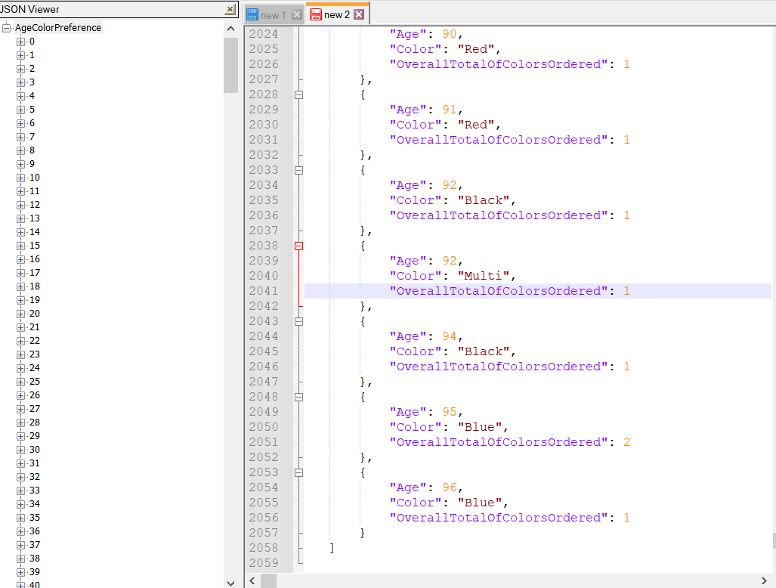

# Proposition 15: Determine whether or not products that have a unit price greater than 1000 are in stock during the month of june and december for each year

Explanation: create function to calculate the difference between unitsin and unitsout if the difference is greater than 0 then output the status of the product as in stock if the difference is less than 0 then output the status of the product as not in stock

## Columns from Standard View



## Columns from Key View



## Columns from their respective table in the select clause

|  |  |
| --- | --- |
| Table Name | Column Name |
| FactProductInventory | UnitCost  ProductKey  MovementDate  UnitsIn  UnitsOut |
| DimProduct | ProductKey  EnglishProductName  ModelName |
| DerivedColumn | StockLevel(dbo.UnitsStock function) |

## Order By

|  |  |  |
| --- | --- | --- |
| Table Name | Column Name | Sort |
| FactProductInventory | Month  Year  UnitsCost | Default  Default  DESC |
| DerivedColumn | StockLevel | Default |

## Problem Solving Query

SET ANSI_NULLS ON

GO

SET QUOTED_IDENTIFIER ON

GO

CREATE FUNCTION dbo.UnitStock

(

@UnitsIn INT, @UnitsOut INT

)

RETURNS NVARCHAR(30)

AS

BEGIN

DECLARE @Stock NVARCHAR(30)

SELECT @Stock = CASE

WHEN (@UnitsIn - @UnitsOut) <= 0

THEN 'NOT IN STOCK'

WHEN (@UnitsIn - @UnitsOut) > 0

THEN 'IN STOCK'

ELSE 'Unknown'

END;

RETURN @Stock;

END;

GO

USE AdventureWorksDW2017;

SELECT F.UnitCost,

F.ProductKey,

P.EnglishProductName,

P.ModelName,

DATEPART(MM, F.MovementDate) AS Month,

DATEPART(YYYY, F.MovementDate) AS Year,

dbo.UnitStock(F.UnitsIn, F.UnitsOut) AS Stocklevel

FROM dbo.FactProductInventory AS F

INNER JOIN dbo.DimDate AS D

ON D.DateKey = F.DateKey

INNER JOIN dbo.DimProduct AS P

ON P.ProductKey = F.ProductKey

WHERE (

DATEPART(MM, F.MovementDate) = 6

OR DATEPART(MM, F.MovementDate) = 12

)

AND (F.UnitCost > 1000)

GROUP BY DATEPART(MM, F.MovementDate),

DATEPART(YYYY, F.MovementDate),

dbo.UnitStock(F.UnitsIn, F.UnitsOut),

F.UnitCost,

F.ProductKey,

P.EnglishProductName,

P.ModelName

ORDER BY F.UnitCost DESC,

Month,

Year,

Stocklevel;

## Sample Relational output with total number of rows returned(350)

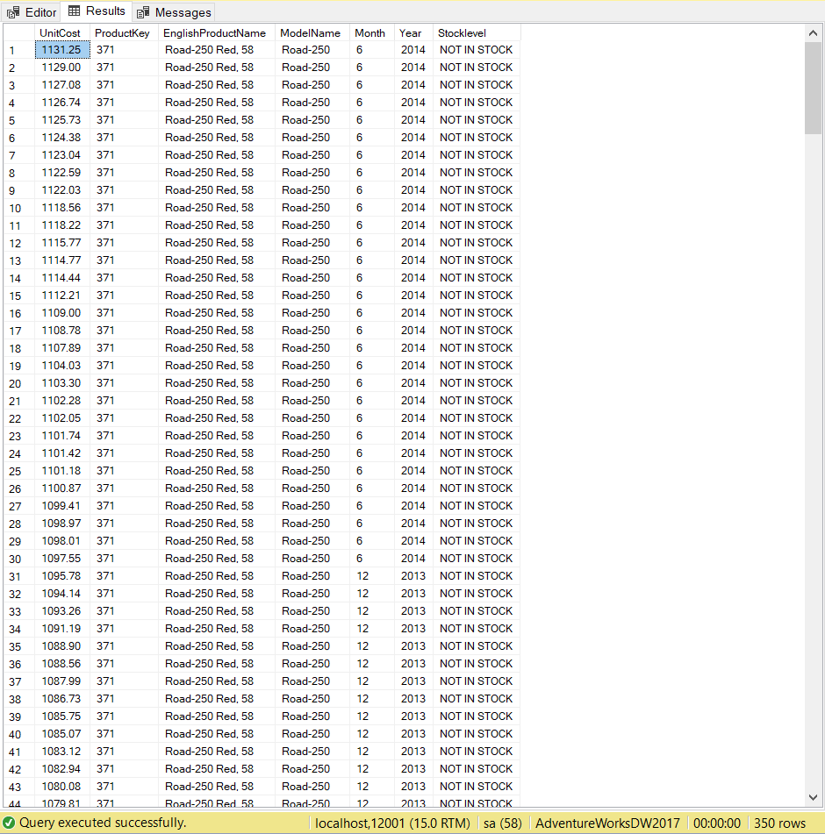

## Sample JSON output with total number of rows returned(350)

USE AdventureWorksDW2017;

SELECT F.UnitCost,

F.ProductKey,

P.EnglishProductName,

P.ModelName,

DATEPART(MM, F.MovementDate) AS Month,

DATEPART(YYYY, F.MovementDate) AS Year,

dbo.UnitStock(F.UnitsIn, F.UnitsOut) AS Stocklevel

FROM dbo.FactProductInventory AS F

INNER JOIN dbo.DimDate AS D

ON D.DateKey = F.DateKey

INNER JOIN dbo.DimProduct AS P

ON P.ProductKey = F.ProductKey

WHERE (

DATEPART(MM, F.MovementDate) = 6

OR DATEPART(MM, F.MovementDate) = 12

)

AND (F.UnitCost > 1000)

GROUP BY DATEPART(MM, F.MovementDate),

DATEPART(YYYY, F.MovementDate),

dbo.UnitStock(F.UnitsIn, F.UnitsOut),

F.UnitCost,

F.ProductKey,

P.EnglishProductName,

P.ModelName

ORDER BY F.UnitCost DESC,

Month,

Year,

Stocklevel

FOR JSON PATH,ROOT('StockLevel'),INCLUDE_NULL_VALUES;

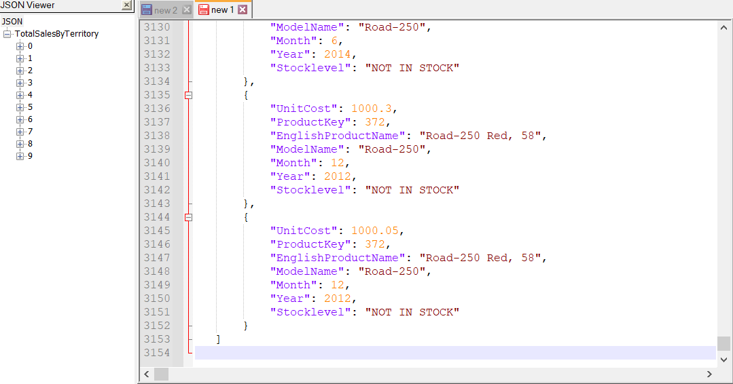

# Proposition 16: How many years did each employee work up to the current date?

How many years did each employee work up to the current date? For every employee, return the organization and department they work in, their job title and full name and calculate the amount of years they worked up until the current year take into account employees that have switched department or quit

## Columns from Standard View



## Columns from Key View



## Columns from their respective table in the select clause

|  |  |
| --- | --- |
| Table Name | Column Name |
| Employee | JobTitle  BusinessEntityID |
| Department | Name  GroupName |
| Person | FirstName  MiddleName  LastName |
| DerivedColumn | FullName(From Person)  YearsWorked(From dbo.YearsInDept Function) |

## Order By

|  |  |  |
| --- | --- | --- |
| Table Name | ColumnName | Sort |
| Employee | BusinessEntityID | ASC |
| Employee | YearsWorked(function) | DESC |

## Problem Solving Query

USE AdventureWorks2017;

SET ANSI_NULLS ON;

GO

SET QUOTED_IDENTIFIER ON;

GO

DROP FUNCTION IF EXISTS dbo.YearsInDept;

GO

CREATE FUNCTION dbo.YearsInDept

(

@EmployeeKey INT

)

RETURNS INT

AS

BEGIN

DECLARE @Years AS INT;

SELECT @Years = CASE

WHEN DH.EndDate IS NULL THEN

DATEDIFF(YEAR, E.HireDate, E.ModifiedDate)

ELSE

DATEDIFF(YEAR, DH.StartDate, DH.EndDate)

END

FROM HumanResources.EmployeeDepartmentHistory AS DH

INNER JOIN HumanResources.Employee AS E

ON E.BusinessEntityID = E.BusinessEntityID

WHERE E.BusinessEntityID = @EmployeeKey;

RETURN @Years;

END;

GO

SELECT E.BusinessEntityID,

D.Name,

D.GroupName,

E.JobTitle,

CONCAT_WS(', ', P.FirstName, P.MiddleName, P.LastName) AS FullName,

dbo.YearsInDept(E.BusinessEntityID) AS YearsWorked

FROM HumanResources.Employee AS E

INNER JOIN HumanResources.EmployeeDepartmentHistory AS DH

ON DH.BusinessEntityID = E.BusinessEntityID

INNER JOIN Person.Person AS P

ON P.BusinessEntityID = E.BusinessEntityID

INNER JOIN HumanResources.Department AS D

ON D.DepartmentID = DH.DepartmentID

GROUP BY CONCAT_WS(', ', P.FirstName, P.MiddleName, P.LastName),

dbo.YearsInDept(E.BusinessEntityID),

E.BusinessEntityID,

E.JobTitle,

DH.DepartmentID,

D.Name,

D.GroupName

ORDER BY E.BusinessEntityID ASC,

YearsWorked DESC;

## Sample Relational output with total number of rows returned(296)

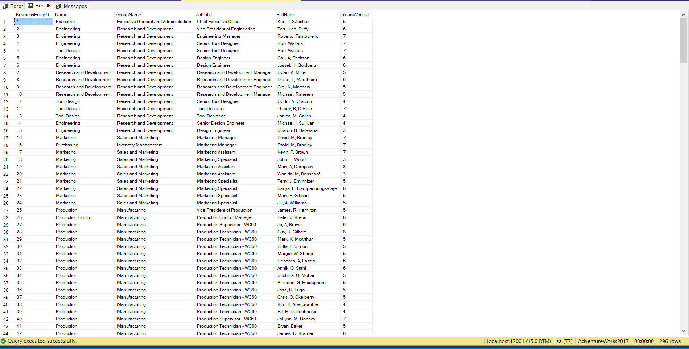

## Sample JSON output with total number of rows returned(296)

SELECT E.BusinessEntityID,

D.Name,

D.GroupName,

E.JobTitle,

CONCAT_WS(', ', P.FirstName, P.MiddleName, P.LastName) AS FullName,

dbo.YearsInDept(E.BusinessEntityID) AS YearsWorked

FROM HumanResources.Employee AS E

INNER JOIN HumanResources.EmployeeDepartmentHistory AS DH

ON DH.BusinessEntityID = E.BusinessEntityID

INNER JOIN Person.Person AS P

ON P.BusinessEntityID = E.BusinessEntityID

INNER JOIN HumanResources.Department AS D

ON D.DepartmentID = DH.DepartmentID

GROUP BY CONCAT_WS(', ', P.FirstName, P.MiddleName, P.LastName),

dbo.YearsInDept(E.BusinessEntityID),

E.BusinessEntityID,

E.JobTitle,

DH.DepartmentID,

D.Name,

D.GroupName

ORDER BY E.BusinessEntityID ASC,

YearsWorked DESC

FOR JSON PATH, ROOT('EmployeeYearsWorked'),INCLUDE_NULL_VALUES;

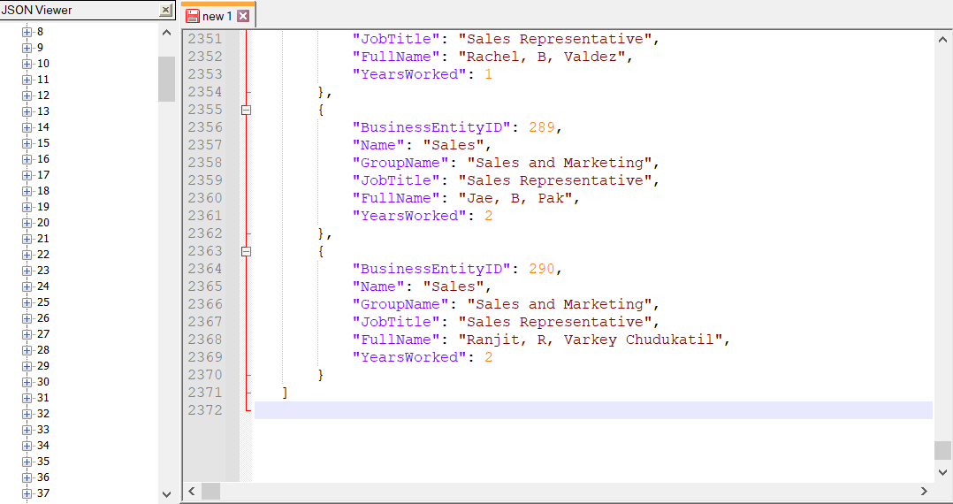

# Proposition 17: Find all the products that were rejected

Explanation: Find all products that were rejected and include the name of the product, vendorid of the vendor who dealt with the product and the amount of items rejected

## Columns from Standard View



## Columns from Key View



## Columns from their respective table in the select clause

|  |  |
| --- | --- |
| Table Name | Column Name |
| PurchaseOrderDetail | ProductID |
| PurchaseOrderHeader | VendorID |
| Product | Name |
| DerivedColumn | RejectedItems(dbo.RejectedProducts function) |

## Order By

|  |  |  |
| --- | --- | --- |
| Table Name | Column Name | Sort |
| DerivedColumn | RejectedItems | DESC |

## Problem Solving Query

USE AdventureWorks2017;

SET ANSI_NULLS ON;

GO

SET QUOTED_IDENTIFIER ON;

GO

DROP FUNCTION IF EXISTS dbo.RejectedProducts;

GO

CREATE FUNCTION dbo.RejectedProducts

(

@productId INT

)

RETURNS DECIMAL(8, 2)

AS

BEGIN

DECLARE @RejectedQty INT;

SELECT @RejectedQty = POD.RejectedQty

FROM Purchasing.PurchaseOrderDetail AS POD

WHERE POD.ProductID = @productId

AND POD.RejectedQty > 0;

IF (@RejectedQty IS NULL)

SET @RejectedQty = 0;

RETURN @RejectedQty;

END;

GO

SELECT PO.ProductID,

P.Name AS ProductName,

POH.VendorID,

dbo.RejectedProducts(PO.ProductID) AS RejectedItems

FROM Purchasing.PurchaseOrderDetail AS PO

INNER JOIN Purchasing.PurchaseOrderHeader AS POH

ON POH.PurchaseOrderID = PO.PurchaseOrderID

INNER JOIN Purchasing.Vendor AS V

ON V.BusinessEntityID = POH.VendorID

INNER JOIN Production.Product AS P

ON P.ProductID = PO.ProductID

GROUP BY dbo.RejectedProducts(PO.ProductID),

PO.ProductID,

P.Name,

POH.VendorID,

V.Name

ORDER BY RejectedItems DESC OFFSET 0 ROWS FETCH FIRST 100 ROWS ONLY;

## Sample Relational output with total number of rows returned(100)

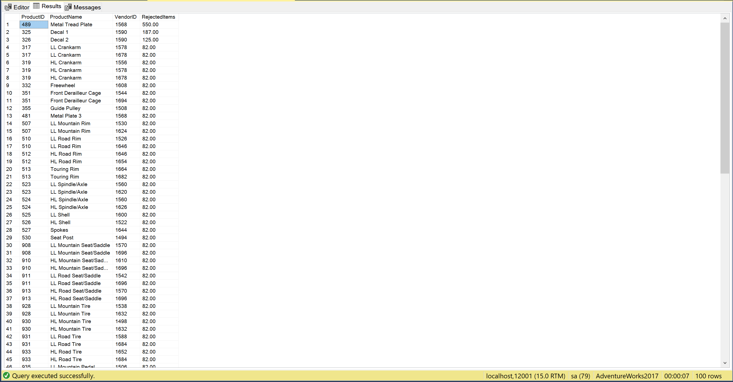

## Sample JSON output with total number of rows returned(100)

USE AdventureWorks2017;

SELECT PO.ProductID,

P.Name AS ProductName,

POH.VendorID,

dbo.RejectedProducts(PO.ProductID) AS RejectedItems

FROM Purchasing.PurchaseOrderDetail AS PO

INNER JOIN Purchasing.PurchaseOrderHeader AS POH

ON POH.PurchaseOrderID = PO.PurchaseOrderID

INNER JOIN Purchasing.Vendor AS V

ON V.BusinessEntityID = POH.VendorID

INNER JOIN Production.Product AS P

ON P.ProductID = PO.ProductID

GROUP BY dbo.RejectedProducts(PO.ProductID),

PO.ProductID,

P.Name,

POH.VendorID

ORDER BY RejectedItems DESC OFFSET 0 ROWS FETCH FIRST 100 ROWS ONLY

FOR JSON PATH,ROOT('Reject_Products'),INCLUDE_NULL_VALUES;

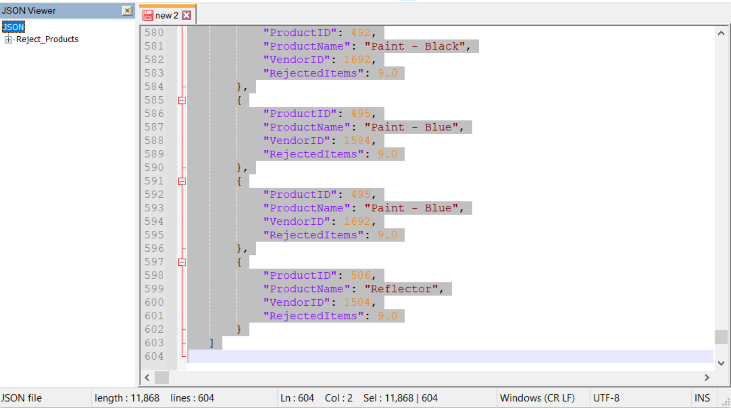

# Proposition 18:Find the top 5 most expensive products to ship

Explanation: find the top 5 most expensive products to ship based on the ship rate by the weight of the product in pounds(LB) plus the shippers base ship rate

## Columns from Standard View



## Columns from Key View



## Columns from their respective table in the select clause

|  |  |
| --- | --- |
| Table Name | Column Name |
| SalesOrderDetail | ProductID |
| ShipMethod | ShipMethodID  ShipBase  ShipRate  Name |
| Derived Column | ShipPrice (from dbo.ProductWeightLb) |

## Order by

|  |  |  |
| --- | --- | --- |
| Table Name | Column Name | Sort |
| DerivedColumn | ShipPrice | DESC |

## Problem Solving Query

USE AdventureWorks2017;

GO

SET ANSI_NULLS ON;

GO

SET QUOTED_IDENTIFIER ON;

GO

DROP FUNCTION IF EXISTS dbo.ProductWeightLB;

GO

CREATE FUNCTION dbo.ProductWeightLB

(

@productId INT

)

RETURNS DECIMAL(8, 2)

AS

BEGIN

DECLARE @Weight DECIMAL(8, 2);

SELECT @Weight = P.Weight

FROM Production.Product AS P

WHERE P.ProductID = @productId;

RETURN @Weight;

END;

GO

USE AdventureWorks2017;

SELECT MAX(DISTINCT SOD.ProductID) AS ProductID,

Ship.ShipMethodID AS ShipperId,

Ship.Name AS ShipperName,

(Ship.ShipBase + Ship.ShipRate * dbo.ProductWeightLb(P.ProductID)) AS ShipPrice

FROM Sales.SalesOrderHeader AS SOH

INNER JOIN Purchasing.ShipMethod AS Ship

ON Ship.ShipMethodID = SOH.ShipMethodID

INNER JOIN Sales.Customer AS C

ON C.CustomerID = SOH.CustomerID

INNER JOIN Sales.SalesOrderDetail AS SOD

ON SOD.SalesOrderID = SOH.SalesOrderID

INNER JOIN Production.Product AS P

ON P.ProductID = SOD.ProductID

WHERE P.WeightUnitMeasureCode = 'LB'

GROUP BY (Ship.ShipBase + Ship.ShipRate * dbo.ProductWeightLb(P.ProductID)),

Ship.ShipMethodID,

Ship.Name

ORDER BY ShipPrice DESC OFFSET 0 ROWS FETCH NEXT 5 ROWS ONLY

--FOR JSON PATH,ROOT('MostExpensiveShipments'),INCLUDE_NULL_VALUES;

## Sample Relational output with total number of rows returned(5)

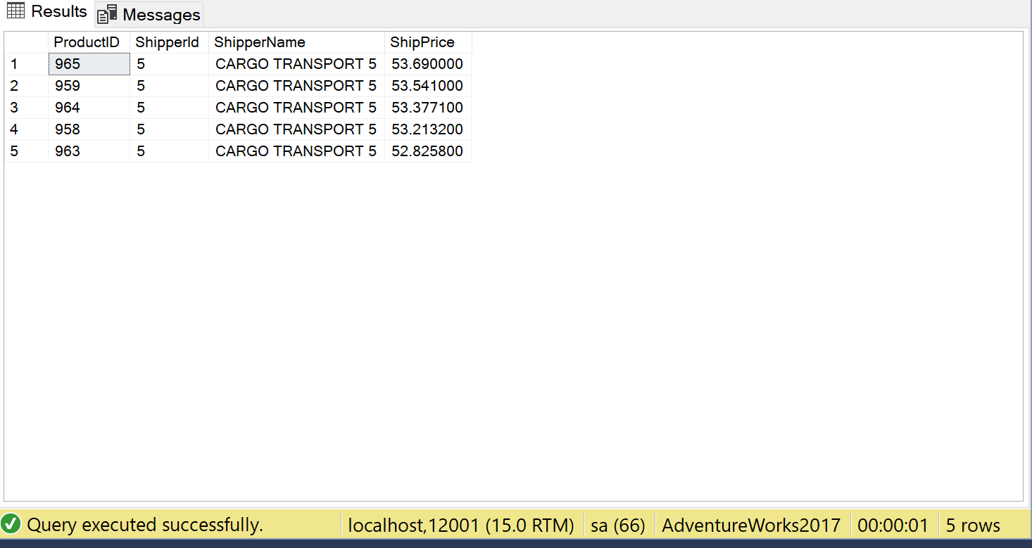

## Sample JSON output with total number of rows returned(5)

USE AdventureWorks2017;

SELECT MAX(DISTINCT SOD.ProductID) AS ProductID,

Ship.ShipMethodID AS ShipperId,

Ship.Name AS ShipperName,

(Ship.ShipBase + Ship.ShipRate * dbo.ProductWeightLB(P.ProductID)) AS ShipPrice

FROM Sales.SalesOrderHeader AS SOH

INNER JOIN Purchasing.ShipMethod AS Ship

ON Ship.ShipMethodID = SOH.ShipMethodID

INNER JOIN Sales.Customer AS C

ON C.CustomerID = SOH.CustomerID

INNER JOIN Sales.SalesOrderDetail AS SOD

ON SOD.SalesOrderID = SOH.SalesOrderID

INNER JOIN Production.Product AS P

ON P.ProductID = SOD.ProductID

WHERE P.WeightUnitMeasureCode = 'LB'

GROUP BY (Ship.ShipBase + Ship.ShipRate * dbo.ProductWeightLB(P.ProductID)),

Ship.ShipMethodID,

Ship.Name

ORDER BY ShipPrice DESC OFFSET 0 ROWS FETCH NEXT 5 ROWS ONLY

FOR JSON PATH, ROOT('MostExpensiveShipments'), INCLUDE_NULL_VALUES;

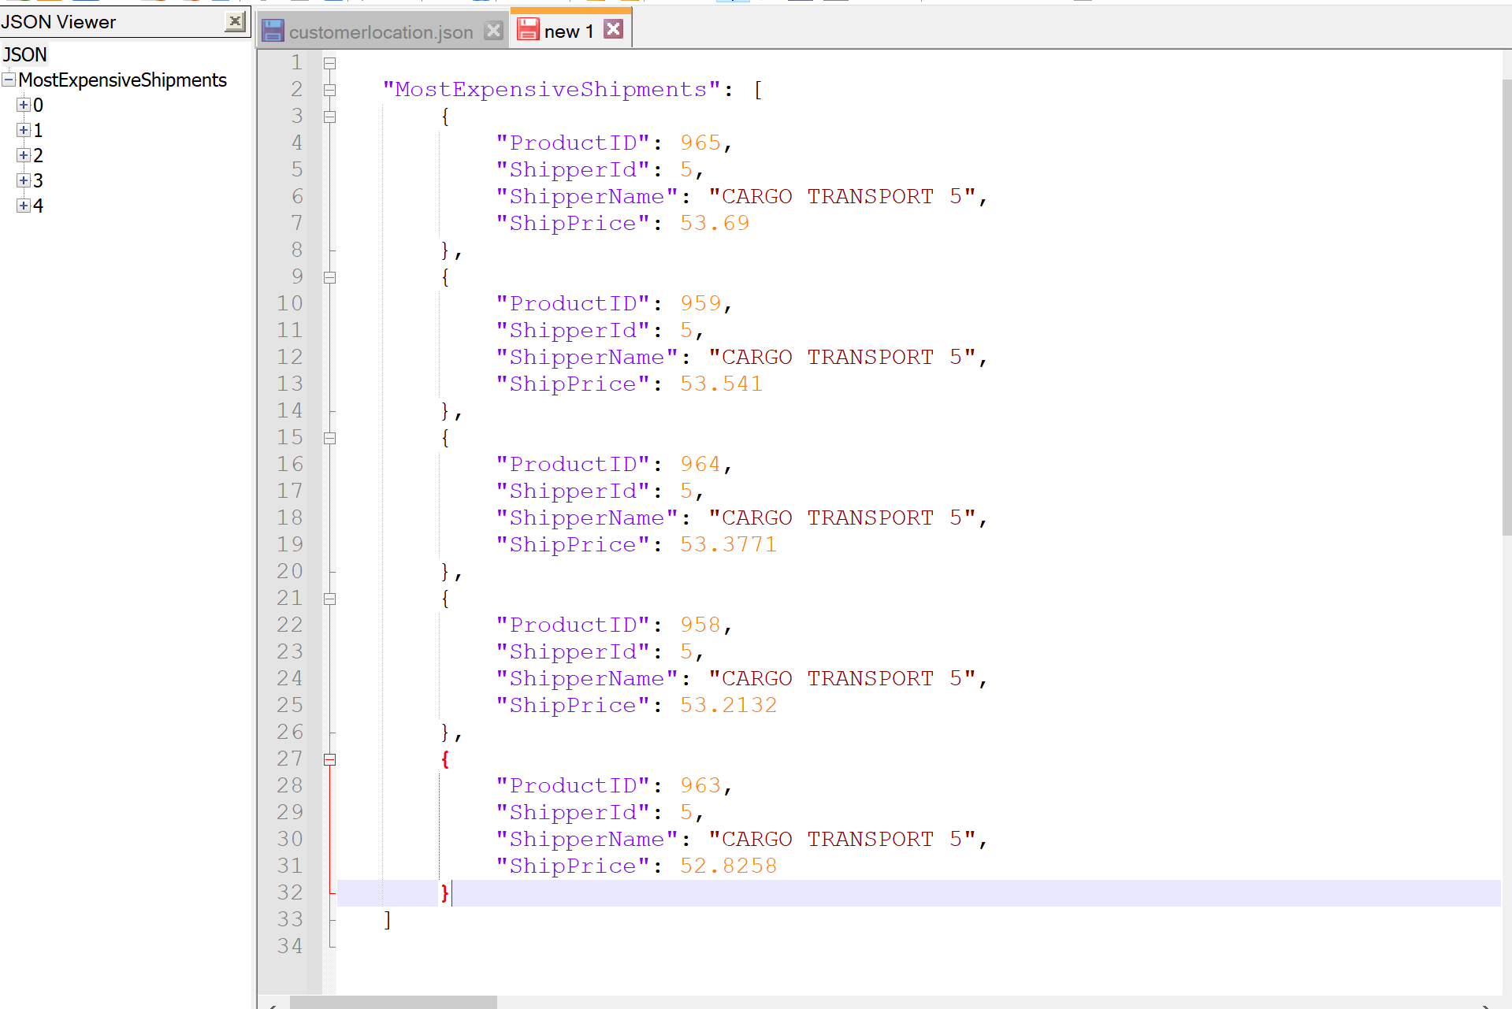

# Proposition 19 Find out if shipments were shipped on time

Explanation: Determine whether a shipment was late, early or on time for each customer based on the difference between the requireddate of the order and the ship date and include the customerid, amount of orders shipped to them, the shippercompany that shipped those orders and the customers country

## Columns from Standard View



## Columns from Key View



## Columns from their respective table in the select clause

|  |  |
| --- | --- |
| Table Name | Column Name |
| Order | OrderId  RequiredDate  ShipToDate |
| Shipper | ShipperId |
| Customer | CustomerId  CustomerCountry |
| DerivedColumn | ShippingTime(dbo.ShipTime function) |

## Order By

|  |  |  |
| --- | --- | --- |
| Table Name | Column Name | Sort |
| Customer | CustomerId | DESC |
| DerivedColumn | Shipments | DESC |

## Problem Solving Query

USE Northwinds2020TSQLV6;

SET ANSI_NULLS ON;

GO

SET QUOTED_IDENTIFIER ON;

GO

CREATE FUNCTION dbo.shipTime

(

@orderid INT,

@requireddate DATE,

@shiptodate DATE

)

RETURNS NVARCHAR(30)

AS

BEGIN

DECLARE @shiptime NVARCHAR(30);

SELECT @shiptime = CASE

WHEN DATEDIFF(DAY, O.RequiredDate, O.ShipToDate) < 0 THEN

'Late Shipment'

WHEN DATEDIFF(DAY, O.RequiredDate, O.ShipToDate) > 0 THEN

'Shipped Early'

ELSE

'ON TIME'

END

FROM Sales.[Order] AS O

WHERE O.OrderId = @orderid

AND O.RequiredDate = @requireddate

AND O.ShipToDate = @shiptodate;

RETURN @shiptime;

END;

GO

SELECT DISTINCT

c.CustomerId,

SUM(S.ShipperId) AS Shipments,

S.ShipperCompanyName AS ShipperCompany,

c.CustomerCountry,

dbo.shipTime(O.OrderId, O.RequiredDate, O.ShipToDate) AS ShippingTime

FROM Sales.[Order] AS O

INNER JOIN Sales.Shipper AS S

ON S.ShipperId = O.ShipperId

INNER JOIN Sales.Customer AS c

ON c.CustomerId = O.CustomerId

WHERE dbo.shipTime(O.OrderId, O.RequiredDate, O.ShipToDate) IS NOT NULL

GROUP BY dbo.shipTime(O.OrderId, O.RequiredDate, O.ShipToDate),

c.CustomerId,

S.ShipperCompanyName,

c.CustomerCountry

ORDER BY c.CustomerId DESC,

Shipments DESC;

## Sample Relational output with total number of rows returned(271)

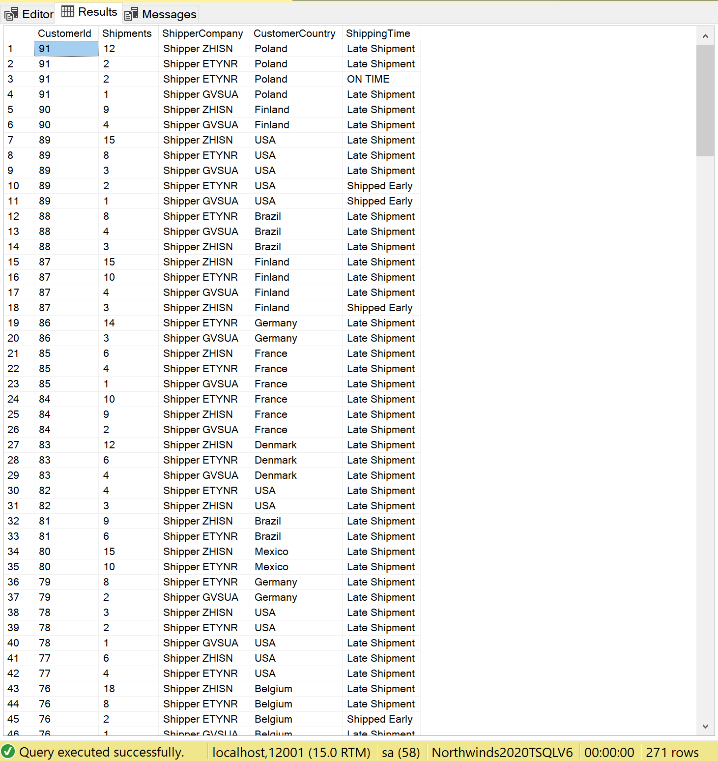

## Sample JSON output with total number of rows returned(271)

SELECT DISTINCT

c.CustomerId,

SUM(S.ShipperId) AS Shipments,

S.ShipperCompanyName AS ShipperCompany,

c.CustomerCountry,

dbo.shipTime(O.OrderId, O.RequiredDate, O.ShipToDate) AS ShippingTime

FROM Sales.[Order] AS O

INNER JOIN Sales.Shipper AS S

ON S.ShipperId = O.ShipperId

INNER JOIN Sales.Customer AS c

ON c.CustomerId = O.CustomerId

WHERE dbo.shipTime(O.OrderId, O.RequiredDate, O.ShipToDate) IS NOT NULL

GROUP BY dbo.shipTime(O.OrderId, O.RequiredDate, O.ShipToDate),

c.CustomerId,

S.ShipperCompanyName,

c.CustomerCountry

ORDER BY c.CustomerId DESC,

Shipments DESC

FOR JSON PATH, ROOT('ShippingTimeStatus'), INCLUDE_NULL_VALUES;

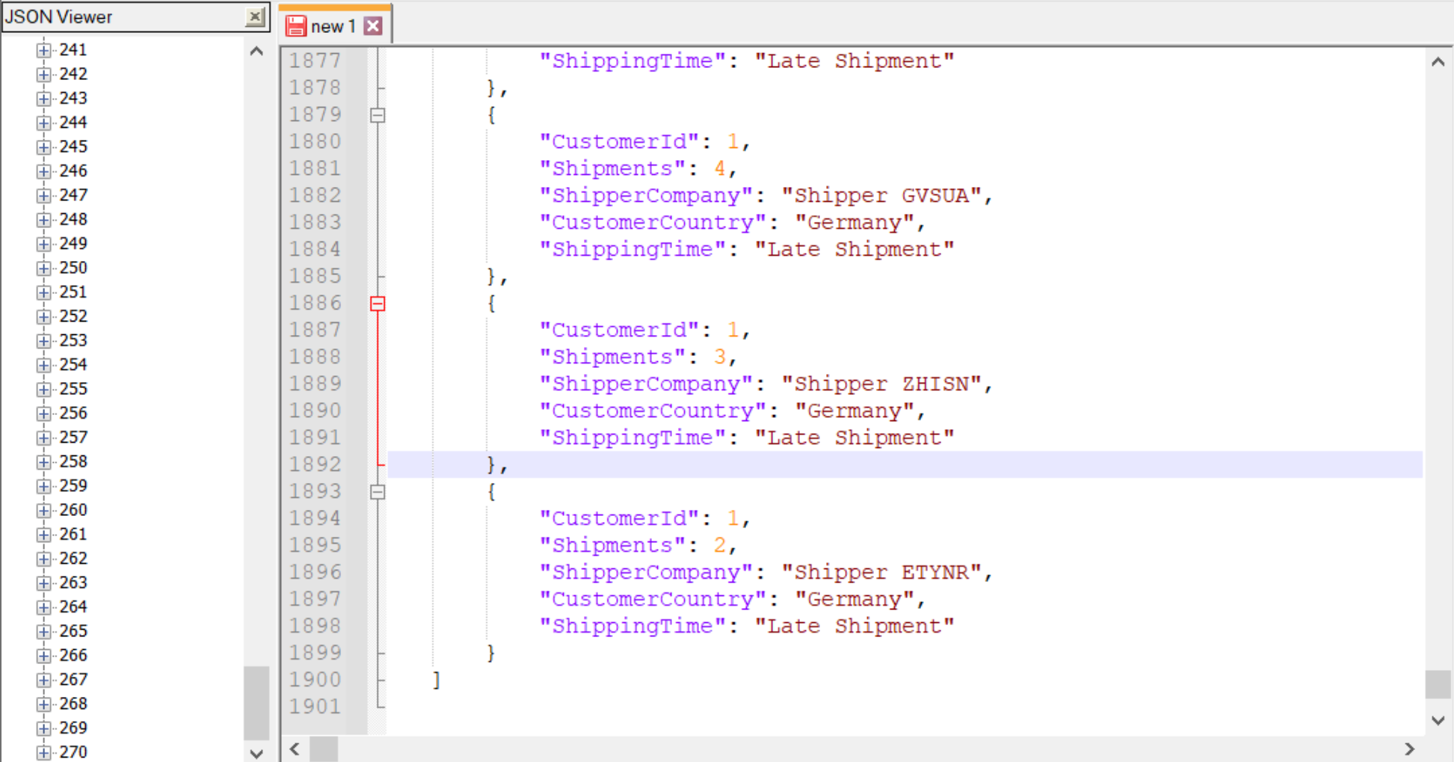

# Proposition 20: Find the top 10 with ties results for the average amount of actual expenses on 12/29/2010 and include the organization, department, account description and type of account

Explanation: Find the top 10 with ties results for the average amount of actual expenses on 12/29/2010 and include the organization, department, account description and type of account

## Columns from Standard View



## Columns from Key View



## Columns from their respective table in the select clause

|  |  |
| --- | --- |
| Table Name | Column Name |
| FactFinance | AccountKey  FinanceKey  DateKey  Date |
| DimAccount | AccountDescription  AccountType |
| DimOrganization | OrganizationName |
| DepartmentGroup | DepartmentGroupName |
| DerivedColumn | AvgAmount(Dbo.SumActualAmount function) |

## Order By

|  |  |  |
| --- | --- | --- |
| Table Name | Column Name | Sort |
| DerivedColumn | AvgAmount | DESC |

## Problem Solving Query

USE AdventureWorksDW2017;

SET ANSI_NULLS ON;

GO

SET QUOTED_IDENTIFIER ON;

GO

CREATE FUNCTION [dbo].SumActualAmount

(

@accountkey INT,

@financekey INT,

@date INT

)

RETURNS FLOAT

AS

BEGIN

DECLARE @Amount FLOAT;

SELECT @Amount = SUM(F.Amount)

FROM dbo.FactFinance AS F

WHERE F.AccountKey = @accountkey

AND F.FinanceKey = @financekey

AND F.ScenarioKey = 1

AND F.DateKey = @date;

IF (@Amount IS NULL)

SET @Amount = 0;

RETURN @Amount;

END;

GO

USE AdventureWorksDW2017;

SELECT TOP 10 WITH TIES F.Date AS AccountDate,

O.OrganizationName,

DG.DepartmentGroupName,

AVg(dbo.SumActualAmount(F.AccountKey, F.FinanceKey, F.DateKey)) AS AvgAmount,

A.AccountDescription AS DescOfAccount,

A.AccountType AS AccountType

FROM dbo.FactFinance AS F

INNER JOIN dbo.DimAccount AS A

ON A.AccountKey = F.AccountKey

INNER JOIN dbo.DimOrganization AS O

ON O.OrganizationKey = F.OrganizationKey

INNER JOIN dbo.DimDepartmentGroup AS DG

ON DG.DepartmentGroupKey = F.DepartmentGroupKey

WHERE dbo.AvgActualAmount(F.AccountKey, F.FinanceKey, F.DateKey) > 0

AND F.DateKey = 20101229

GROUP BY F.Date,

O.OrganizationName,

DG.DepartmentGroupName,

F.FinanceKey,

A.AccountDescription,

A.AccountType

ORDER BY AvgAmount DESC;

## Sample Relational output with total number of rows returned(11)

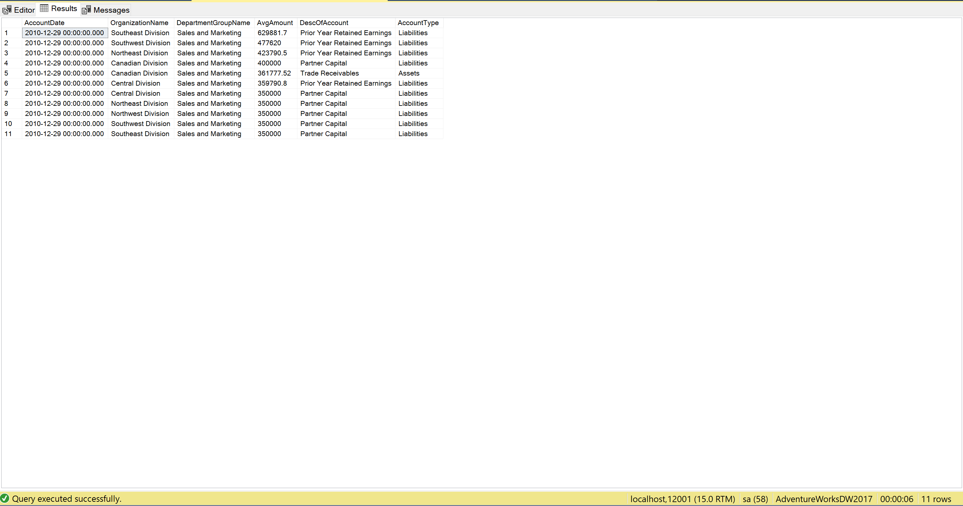

## Sample JSON output with total number of rows returned(11)

USE AdventureWorksDW2017;

SELECT TOP 10 WITH TIES

F.Date AS AccountDate,

O.OrganizationName,

DG.DepartmentGroupName,

AVG(dbo.SumActualAmount(F.AccountKey, F.FinanceKey, F.DateKey)) AS AvgAmount,

A.AccountDescription AS DescOfAccount,

A.AccountType AS AccountType

FROM dbo.FactFinance AS F

INNER JOIN dbo.DimAccount AS A

ON A.AccountKey = F.AccountKey

INNER JOIN dbo.DimOrganization AS O

ON O.OrganizationKey = F.OrganizationKey

INNER JOIN dbo.DimDepartmentGroup AS DG

ON DG.DepartmentGroupKey = F.DepartmentGroupKey

WHERE dbo.AvgActualAmount(F.AccountKey, F.FinanceKey, F.DateKey) > 0

AND F.DateKey = 20101229

GROUP BY F.Date,

O.OrganizationName,

DG.DepartmentGroupName,

F.FinanceKey,

A.AccountDescription,

A.AccountType

ORDER BY AvgAmount DESC

FOR JSON PATH, ROOT('Top10HighestAmounts'), INCLUDE_NULL_VALUES;

